TBN
  - GLAD Solution Architecture Description (SAD)

Contents
2 Document 1
2.1 Section Synopsis 1
2.2 Version, Consultation, Distribution, Review & Approval Schedule 1
2.3 Document Purpose 1
2.4 Document Conventions & Standards 1
2.5 Document Length (TLDR) 1
2.6 Documentation Location 2
2.7 Document Structure 2
2.8 Document Terminology 3
2.8.1 Business Terminology 3
2.8.2 IT Terminology 4
2.9 Related Document Context 5
3 Business Context View 7
3.1 Section Synopsis 7
3.2 Problem Description 7
3.3 Background Summary 7
3.4 Analysis 7
3.4.1 SWOT 7
3.4.2 Business Goals & Objectives, Strategies & Tactics (GOST) 7
3.5 Strategic Alignment 7
3.6 Business Requirements 8
3.7 Scope Exclusion 8
3.8 Stakeholder & Responsibility Context 8
3.9 Schedule Context 9
3.10 Business Constraints Context 10
3.10.1 Laws & Regulations 10
3.10.2 Agreements 10
3.10.3 Organisation Principles 12
3.10.4 Project Principles 12
3.11 Assumptions 12
3.12 Risks 13
3.13 Deliverables 13
3.13.1 Principled Behaviour and Decisions 13
3.13.2 Lifecycle Process over Product 14
3.14 Governance 14
3.15 Business Decisions 14
3.16 Motivational Context 15
3.17 Systems 15
4 Architectural Forces 16
4.1 Section Synopsis 16
4.2 Services and Systems 16
4.3 Architectural Constraints 16
4.4 Architectural Principles 16
5 Architectural Views 17
5.1 Standard Architectural View Descriptions 17
6 System Context View 18
6.1 Section Synopsis 18
6.2 Legal, Regulation & Agreements Context 18
6.2.1 Principles 18
6.3 Sector, Partner, Organisation System Context 18
6.4 Technical Platform Options Considered & Preferred 18
6.4.1 Options Considered 18
6.4.2 Custom Ad-hoc development 19
6.4.3 Reusable Base development first 19
6.4.4 Preferred Option 19
6.5 Domain Context 19
6.6 System Integration Context 21
6.7 Hosting Environment Context 21
7 System User View 22
7.1 Section Synopsis 22
7.2 User Access 22
7.3 User Capabilities & Universal Design 22
7.3.1 Risks 23
7.4 Access Goal Schedule 23
7.4.1 Access by Voice Devices 24
7.4.2 Easier to comprehend content 25
7.4.3 More equitable distribution of Service via lower cost devices 25
7.5 User Characteristics 25
7.6 Individual User Focused 26
7.6.1 Individual Access Context 27
7.7 User Group 27
8 Resource View 29
9 Delivery View 31
9.1 Section Synopsis 31
9.2 Deliverables 31
9.3 Software Development Life cycle 31
9.3.1 ISO-15288 32
9.3.2 Traditional 32
9.3.3 ISO-29110-4-4 & 4-5 Agile & Agile DevOps Life cycle 33
9.4 Risks 34
9.4.1 Risk Register 34
9.4.2 Categories 34
9.4.3 Risks to consider 35
9.5 Reporting 35
9.6 WorkItem Management 35
9.6.1 Waterfall Model versus Agile Model 36
9.6.2 Agile 37
9.7 Application Lifecycle Management Service (AML) Suite 38
9.7.1 Work Item Management Service 39
9.7.2 Agile WorkItems (Epics, Features, User Stories). 39
9.7.3 User Stories 40
9.7.4 Documentation Management Service 41
9.7.5 Source Code Management Service 41
9.7.6 Build & Deployment Pipeline 41
9.7.7 Related Documents 41
9.8 Capability 42
9.9 Deliverables 42
10 Requirements View 45
10.1 Section Synopsis 45
10.2 Source of Requirements 45
10.3 Standards 46
10.4 SMART Objectives 46
10.5 Levels Used 47
10.6 Volatility of Requirements 47
10.6.1 Changes 47
10.6.2 New Requirements 48
10.7 Associated Documents 48
11 Service Information Model View 49
11.1 Section Synopsis 49
11.2 Service Network Information Sets 49
11.3 Service Lifecycle Information Types 50
11.4 Service Lifecycle Information Stages 50
11.5 Information System Information Types 51
11.6 Entity Relationship Model (ERM) Diagrams 52
11.6.1 Overall 52
11.6.2 System Module Management 54
11.6.3 Diagnostics Management 55
11.6.4 Error Management 55
11.6.5 Disclosure and T&C Management 55
11.6.6 Settings Management 55
11.6.7 System Status Management 56
11.6.8 Session Management 56
11.6.9 User Management 57
11.6.10 Identity Management 58
11.6.11 Access Management 59
11.6.12 Notification Management 60
11.6.13 Group Management 60
11.6.14 Organisation Management 60
11.6.15 Resource Collection Management 60
11.7 Resource Lifecycle Management ERM Diagrams 61
11.7.1 High level ERM 61
11.7.2 XXX 65
11.7.3 YYY 66
12 Service Messages View 67
13 Service Information Development View 70
13.1 Synopsis 70
13.2 Qualities 70
13.3 Metadata 71
13.4 Processes 71
13.5 Intellectual Copyright Types 71
13.6 Custom Access & Usage Terms & Conditions 71
14 Service Qualities View 72
14.1 Section Synopsis 72
14.2 Qualities versus Non-Functional Requirements 72
14.3 Constraints 72
14.3.1 ISO-25022:2016 72
14.3.2 ISO-25012 72
14.3.3 ISO-25010 73
14.4 Security Qualities 73
14.5 Functionality Qualities 74
14.6 Usability Qualities 74
14.7 Compatibility Qualities 75
14.8 Reliability Qualities 76
14.9 Performance Qualities 77
14.10 Maintainability Qualities 77
14.11 Portability Qualities 78
14.12 Supportability Qualities 78
15 Service Functionality View 80
15.1 Section Synopsis 80
15.2 Overview 80
15.3 System Management Functionality 80
15.3.1 High Level System Information Management Groups 80
15.3.2 System Configuration Management Operations 81
15.3.3 System Mutable Configuration Management Operations 85
15.3.4 System Module Management Operations 86
15.3.5 System Module Permissions Management Operations 86
15.3.6 System Diagnostics Management Operations 87
15.3.7 System Information Management Operations 88
15.3.8 System Error Management Operations 89
15.3.9 System Status Management Operations 90
15.3.10 Session Management Operations 91
15.3.11 System Authorisation Management Operations 91
15.3.12 System Authentication Management Operations 91
15.3.13 System Auditing Management Operations 91
15.3.14 System Search Management Operations 91
15.3.15 System User Management Operations 92
15.3.16 Notification Management Operations 93
15.3.17 Group Management Operations Organisation Management Operations Group Role Assignment Operations 94
15.3.18 Media Resource Management Operations 94
15.3.19 Media Resource Role Assignment Operations 94
15.3.20 Reporting Operations 94
15.3.21 Monitoring & Alerting Operations 94
15.3.22 Dashboard Management Operations 94
15.4 Media Management Functionality 95
15.4.1 High Level Overview 95
15.4.2 Media Metadata Functionality 96
15.4.3 Media Validation Functionality 97
15.4.4 Media Feedback Validating Functionality 97
15.4.5 Media Semantic Structure Enforcement 97
15.4.6 Media Association Functionality 98
16 Service Workflows View 102
16.1 Section Synopsis 102
16.2 Command Queue 102
16.3 Async Operations 102
16.4 Batch Operations 102
16.5 System Workflows 102
16.5.1 Onboarding 103
16.5.2 Group Membership Invitations Workflow 103
16.5.3 Develop & Publish Parent Group (or Organisation) Terms & Conditions 104
16.5.4 System Notification Publishing 105
16.5.5 Parent Group (or Organisation) Notification Publishing 106
16.6 Media Management Workflows 107
16.6.1 Media States 107
16.6.2 Media Development Workflow 107
16.6.3 Resource Approval Workflow 108
16.6.4 Collecting Resource User Voice 110
16.6.5 Using Resource User Feedback 111
17 Service Integration View 112
17.1 Section Synopsis 112
17.2 Integration Authentication Patterns 112
17.3 Constraints 113
17.3.1 Integration Principles 113
17.4 Protocols 114
17.4.1 ISO-27001 Stage 2+ Physical Environment 116
17.5 Network 116
17.6 Message 116
17.7 Service Devices 116
17.8 Components 116
17.9 Services 116
17.9.1 Storage Services 118
17.9.2 Caching Service 118
17.9.3 Notification (SMTP) Service 118
17.9.4 Identity Service 118
17.9.5 Malware Detection Service 118
17.9.6 Search Service 118
17.10 Enterprise Services 119
17.10.1 Analysis & Reporting Database Development 119
17.10.2 Data Warehouse 120
17.11 Integration Schedule 121
18 Service Interoperability View 123
18.1 Section Synopsis 123
18.2 About APIs 123
18.2.1 Service Façade 123
18.2.2 Web based APIs 123
18.2.3 Service Web Redirection 123
18.2.4 Service DTOs 123
18.2.5 Service DTO Security 124
18.2.6 Service Versioning 124
18.2.7 Service Information Queryability, Selection, Projection and Paging 124
18.2.8 Service Headers 124
18.2.9 Service Discoverability 124
18.2.10 Modular APIs 124
18.3 Base Module REST APIs 125
18.3.1 Diagnostics Management Service Facade API Schema 125
18.3.2 Error Management Service Facade API Schema 125
18.3.3 Session Management Service Facade API Schema 126
18.3.4 Session Operations Management Service Facade API Schema 126
18.3.5 Tenancy Management Service Facade API Schema 127
18.3.6 Group Management Service Facade API Schema 127
18.3.7 Organisations Management Service Facade API Schema 128
18.3.8 Member Management Service Facade API Schema 128
18.3.9 [Origin] Country Management Service Facade API Schema 129
18.3.10 Parent Group Role Management Service Facade API Schema 129
18.3.11 Data Category Management Service Facade API Schema 130
18.3.12 Notification Type Management Service Facade API Schema 130
18.3.13 Notification Management Service Facade API Schema 131
18.3.14 Invitation Management Service Facade API Schema 131
18.3.15 Search SynopsisItem Service Facade API Schema 132
18.4 Media Functionality Service Façade REST APIs 133
18.5 OCH Functionality Service Façade APIs 133
19 Service Deployment View 135
19.1 Section Synopsis 135
19.2 Environments 135
19.2.1 Common Resource Groups 136
19.3 Packages 137
20 Service Operations View 139
20.1 Synopsis 139
20.2 Project Documentation 139
20.3 Internal Corporate Registries 139
20.4 Operations Manual 139
20.5 Domain Name Service (DNS) 139
20.6 Host Environments 139
20.7 Key System components 139
20.8 Service Accounts 140
20.8.1 Deployment Service Account 140
20.8.2 Service System Service Account 140
20.9 Service Credentials 140
20.9.1 Certificate Development 140
20.9.2 Cloud Provider Services 141
20.9.3 3rd Party Services 141
20.10 Certificates 141
20.11 Infrastructure as Code 142
20.11.1 In Azure 142
20.11.2 In Amazon 142
20.12 Operating System and Execution Environment Patching 142
20.12.1 Azure 142
20.13 System Configuration 142
20.14 System Diagnostics Tracing 142
20.15 System Monitoring 143
20.15.1 Deploying to Azure 143
20.15.2 Deploying to Amazon 143
20.16 System Alerting 143
20.16.1 Deploying to Azure 143
20.16.2 Deploying to Amazon 144
20.17 Data Archiving 144
20.18 Reports 144
21 Service Security View 145
21.1 Section Synopsis 145
21.1.1 Overview 145
21.2 Behaviour 145
21.2.1 Non-Access to Production Data 145
21.3 Production Tools 146
21.4 Physical Environment Security 146
21.4.1 Confidentiality 146
21.4.2 Integrity 146
21.4.3 Availability 146
21.5 Network Security 147
21.5.1 Azure Cloud Service Network Environment Characteristics 147
21.5.2 Amazon Cloud Service Environment Network Environment Characteristics 147
21.6 Host Security 147
21.6.1 Azure PaaS Characteristics 147
21.6.2 Azure Container Characteristics 147
21.7 System Information Security 147
21.7.1 Confidentiality 147
21.7.2 Integrity 151
21.7.3 Availability 152
21.7.4 Data Classification 155
21.8 Roles to Permissions Schedule 156
22 Service Privacy View 157
22.1 Section Synopsis 157
22.2 Constraints 157
22.2.1 Regulation 157
22.2.2 Principles 157
22.3 Use Cases 157
22.3.1 Privacy & Minimum Data Collection 157
22.3.2 Privacy & Tracking Policy 157
22.3.3 PII & Analysis and Reporting Requirements 158
22.3.4 PII & Data Warehouse 158
22.3.5 PII & "Right to be Forgotten (R2BF)" Requests 158
23 Service Quality Assurance View 159
23.1 Section Synopsis 159
23.2 Background 159
23.3 Constraints 159
23.3.1 Testing Principles 159
23.4 Decisions 159
23.5 Technologies 160
23.6 Test Types 160
23.7 Best Practice 161
23.8 Test Data 162
23.8.1 Data Migration Testing 162
23.9 Process 162
23.10 Examples 164
23.10.1 Desires 164
23.10.2 Work Item 164
23.10.3 Acceptance Tests 165
23.11 Functional Testing 165
23.11.1 API Service Façades 165
23.11.2 Web User Interface 167
23.12 Quality Testing 167
23.12.1 Prioritization of Quality Testing 168
23.13 Summary 169
24 Service Data Storage Development View 170
24.1 Section Synopsis 170
24.2 Governance 170
24.2.1 Self-Governance 170
24.3 Technologies 170
24.3.1 Object/Relational Mapping (ORM) 170
24.4 Security 170
24.4.1 Service Account 170
24.4.2 Connection Strings 170
24.4.3 Security in Transit 171
24.4.4 Security at Rest 171
24.4.5 Database Backups and Restorations 172
24.4.6 XXXX: TODO 173
25 Service Development View 174
25.1 Section Synopsis 174
25.2 Governance 174
25.2.1 Self-Governance 174
25.3 Principled Design 174
25.4 Principled Development 174
25.4.1 Technical Decision Registry 175
25.4.2 Standards 175
25.5 Constraints 179
25.5.1 Regulations 180
25.5.2 Principles 180
25.6 Best Practices 180
25.6.1 Test Driven 180
25.6.2 Documented 181
25.6.3 Loose Coupling, High Cohesion 181
25.6.4 Real-time Notification over Delayed Batch notification 181
25.7 Protocols 181
25.8 Development Patterns 181
25.8.1 Pull-Requests 183
25.8.2 Verified Code Branch Integration 183
25.8.3 Automated Tests 183
25.8.4 Component Design Patterns 184
25.8.5 Object Oriented Development 188
25.8.6 SOLID Object Oriented (OO) Development Patterns 188
25.8.7 Test-Driven Development 189
25.9 Technologies 190
25.9.1 .NET Core Based Development 190
25.10 Stakeholders 190
25.10.1 Testers 190
25.11 Components 191
25.11.1 Packages 191
25.11.2 Classes 191
25.12 Security 191
25.12.1 Configuration Information 192
25.12.2 Service Integration Credentials & Key Vaults 192
25.12.3 In Transit 192
25.12.4 OWASP 192
25.13 API Development 192
25.13.1 API Versioning 192
25.13.2 Notification & Redirection 193
25.14 Services 193
25.14.1 Base Infrastructure Services 193
25.15 Service Façade 194
25.15.1 Base Module 194
25.16 Business Module's Service Facade 195
26 Service Client Development View 196
26.1 Constraints 196
26.1.1 International Standard Technologies and Protocols 196
26.1.2 Non-International Standard Technologies 197
26.2 Technologies 197
26.2.1 Accessibility Devices 197
26.2.2 Smallest Channel Device 198
26.2.3 Mobile Web Channel 199
26.2.4 Service Client Stack 199
26.3 Best Practices 200
26.3.1 MVC Pattern 200
27 Service Client User Interface Development View 202
27.1 Section Synopsis 202
27.2 Web Channel 202
27.2.1 Constraints 202
27.3 Web Channel Structure 202
27.3.1 Semantic Web 202
27.3.2 WAI-ARIA 203
27.3.3 Role HTML Attributes 203
27.3.4 ARIA Form Attributes 204
27.3.5 Combined Semantic and ARIA Example 205
27.3.6 Additional Information 206
27.4 Theming Framework 207
27.5 View Copy 207
27.5.1 Plain Language 207
27.5.2 Copyright Material 208
27.5.3 Localisation 208
27.6 View Framework 210
27.6.1 Angular 210
27.6.2 Vue.JS 210
27.6.3 React 210
27.7 Navigation 210
27.7.1 Action Based Design 210
27.7.2 View Flows 210
27.8 Security 212
27.8.1 In Transit 212
27.8.2 Cookies 212
27.8.3 Redirection 213
27.8.4 OWASP 213
27.9 Related Documentation 213
28 Service Client View Development View 214
28.1 Synopsis 214
28.2 View Types 214
28.3 Shell Container View 215
28.4 The Overlay Container View 215
28.4.1 Splash Screen View 215
28.4.2 Synchronous Flash Status View 216
28.4.3 Modal Confirmation View 216
28.4.4 Login Container View 216
28.5 Content Container View 216
28.6 Context Container View 217
28.7 Navigation Context View 218
28.8 Status Container View 218
28.8.1 System Status Output View 219
28.8.2 Tenant Status Output View 219
28.8.3 Organisation Status Output View 219
28.8.4 Group Status Output View 219
28.8.5 Operation Queue Status Output View 220
28.8.6 Operation Status Output View 220
28.9 Body Container View 220
28.10 Public Module Container View 221
28.10.1 Home Page View 221
28.10.2 Other Public Views 221
28.11 Base Module Container View 222
28.11.1 Diagnostics & Error Content View 222
28.11.2 Session Auditing Container View 223
28.11.3 System Container View 224
28.11.4 Settings Container View 225
28.11.5 Dashboard Container View 226
28.11.6 Search Container View 227
29 Service Client User Interface View Flow View 229
29.1 Dashboard View and Related Flows 229
29.1.1 Customizable Dashboard & Dashboard Tiles 230
29.2 Group View & Related Information Flows 231
29.3 Invitation of a Member to a Group Role 231
29.4 Editing Group Roles 232
30 Service Client User Interface Design View 234
30.1 Avoiding Delivery Risk 234
30.1.1 Identical displays are not an objective 234
30.1.2 Mobile Web Screen Size First 234
30.2 Action Driven 234
30.3 Action Copy 234
30.4 Behaviour 234
30.4.1 Scrolling 234
30.5 Colours 235
30.5.1 Colour Blindness 235
30.5.2 Colour Contrast 235
30.6 Images 235
30.6.1 Large images 235
30.6.2 Colourful background Images 236
30.7 Icons 236
30.7.1 Single Tone, Outline Icons 236
30.7.2 Fonts & Vector based Icons 237
30.8 Space 238
30.8.1 Wasted Space 238
30.8.2 Effective Space 238
31 Appendices 239
31.1 Section Synopsis 239
31.2 Document 239
31.2.1 Document Conventions 239
31.2.2 Document Structure 239
31.2.3 Document Audience 239
31.2.4 Document Asides 240
31.2.5 Document Formatting Conventions 241
31.3 Project 241
31.3.1 Background History (Extended) 241
31.4 Acronyms & Terms 241
31.4.1 Terms 241
31.4.2 Mōari Terms 244
31.4.3 Acronyms 248
31.5 Risks 250
31.5.1 Direction 250
31.5.2 Delivery 250
31.5.3 Discovery 250
31.5.4 Definition 251
31.5.5 Design 251
31.5.6 Development 251
31.5.7 Quality Assurance 251
31.5.8 Deployment 251
31.5.9 Support 251
31.5.10 Operations 251
31.5.11 Maintenance 252
31.5.12 Decommissioning 252
31.6 Principles 252
31.6.1 Summary of Principles Applicable to NZ National Services 252
31.6.2 NZ Privacy Principles 252
31.6.3 NZ Specific - Digital Standards Principles 253
31.6.4 NZ National Service Specific – Digital Service Design Standards Principles 253
31.6.5 NZ National Service Specific – Data and Information Management Principles 254
31.6.6 NZ MOE Enterprise Design Principles 255
31.6.7 Universal Design Principles 256
31.6.8 Organisation Principles 258
31.7 Delivery Methodologies 267
31.7.1 Comparison of Methodologies 267
31.7.2 Agile 268
31.8 Requirements 269
31.8.1 Functional Requirements 269
31.8.2 Quality Requirements 270
31.9 Required Effort expressed as Work Items 272
31.9.1 Delivery Service 272
31.9.2 Information Service 272
31.9.3 Service Client 273
31.9.4 Epics 276
31.9.5 Features 277
31.9.6 Tasks 279
31.10 Development 279
31.10.1 Integration 279
31.11 Integration 282
31.11.1 Security 282

Document
This section of the document describes the history, conventions and structure of the rest of the document.

Section Synopsis
This document follows industry standards to describe a complex model of an project in multiple views for review by domain specialists prior to committing development resources.

Version, Consultation, Distribution, Review & Approval Schedule
- Version 0.1: 5 Aug 2010, Draft

Document Purpose
The purpose of a SAD is to diminish the risk of non-delivery of the expected service & system outcomes of a project.
Risk is reduced by making available to domain specialists a common resource to review, raise concerns before work commences, avoiding later re-litigation or mistakes from lack of forethought and review.
Risk is further reduced by maintaining this resource up to date to provide different stakeholder groups current trustable reviewed instructions.

Document Conventions & Standards
This document uses ISO specified industry conventions and standards for structure, notation, diagrams and delivery approach.
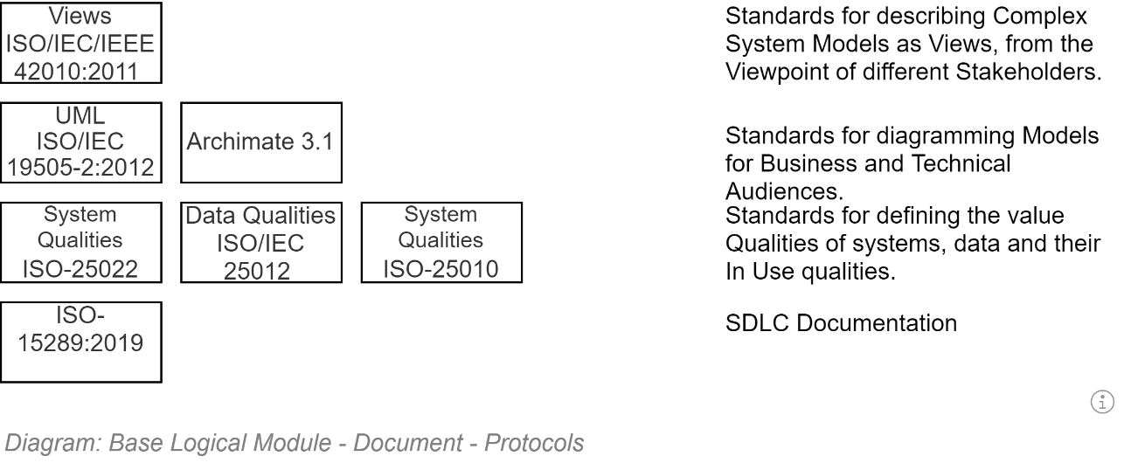
Note:
ISO:42010:2011 specifies that complex systems – such as the system described within this description document – are described in a series of Views (in other words, chapters) from the perspective of different Stakeholders.
In this document, Views / Chapters have been developed to address concerns of Stakeholders interested in Organisation Strategy, Business Services, Security, Privacy, Information, Development, Infrastructure, Deployment, Communications, etc.

Document Length (TLDR)
“It’s too long!”
As described in the next section, the document is not meant to be read in its entirety by any stakeholder group – including reviewers.
It is not a novel. Nor a summary. It is a manual to reduce unnecessary risks to deliver a software project.
There is duplication between view sections, as information relevant to one stakeholder group may be also relevant to another stakeholder group.
The S in the title stands for Solution – not Short. Its length should be the length necessary to decrease the risk of misunderstanding how to implement the Solution. Depending on the project, it can get long.
Warning
Writing a shorter presentation summary description document may produce something that is easier to carry around. But would be insufficient to demonstrate two key aspects:
- whether sufficient thought was invested in discovering and designing for the interaction between different systems and stakeholders
- whether sufficient thought has been invested in addressing common project risks and defining controls and mitigations to not expose the project and its stakeholders to unnecessary risk of failure.

Documentation Location
This manual’s contents would be best served being hosted as a publicly accessible project wiki, ensuring stakeholders can find, access and keep current its contents.

Document Structure
Solution Architecture Descriptions (SADs) are generally too large to be effectively read in their entirety by all stakeholders.
As per ISO 42010:2011 this SAD is divided into different sections (“Views”) for review and reference by different stakeholder groups.
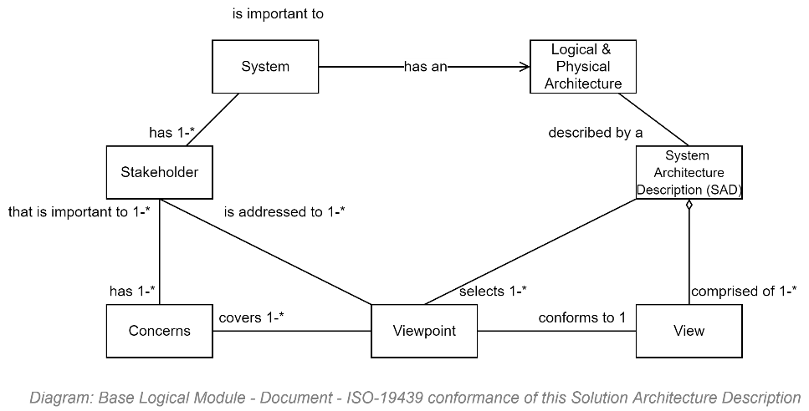
The sections are divided to answer the concerns from different perspectives.
Standard Key Views include but are not limited to:
- A Strategic & Business Context View, addressing the system’s strategic expected value
- A System Context View, addressing where the system is within existing systems
- A System User Context View, addressing who can access the system
- A System Information View, addressing the types of information the system manages
- A Requirement Definition View, addressing how stakeholder desires are captured as Work Items.
- A Security View, addressing how the systems key asset – it is information – is protected
- A User Privacy View, addressing concerns about system user privacy.
- A Functionality View, addressing the functionality developed to change the information
- A System Qualities View, answering what level of quality to expect of the system
- An Integration View, addressing how the service will be integrated & reuse other services
- A Deployment View, addressing how the service will be delivered to target host devices
- A Testing Definition View, addressing how the system’s qualities & functionality targets are defined as testable outcomes
- A Development View, addressing how the test targets are automated and then system is developed to meet the automated test targets
- Etc – dependent on the project.

Document Terminology
Below are listed a minimal preliminary selection of terms that may facilitate reading of this document.
Note:
the appendices provide a more complete listing of terms.

Business Terminology
TODO: Suggestions:
- Business Capability
- Business Service
- Business Function
- Business Process
- RASCI: Responsible, Accountable, Supporting, Consulted, Informed.
CRIMEAS is a similar acronym standing for: Consulted, Responsible, Informed, Managing, Everyone else, Accountable, Supporting.
- Role: a logical assembly of Responsibilities and Permissions, which are conferred on one or more Persons within a purposeful Group of persons.
- Stakeholder: an RASCI member of a purposeful Group of Persons.
- Steward: acting on behalf of an Owner, has the same responsibilities and opportunities as an Owner, bar the Accountability.
- Owner: the single Accountable person.

IT Terminology
- Agile [delivery methodology]: a respected approach to technology delivery at pace by experienced resources working together with minimal planning, oversight & documentation overhead. The methodology emphasises rapid and iterative delivery of change for user stakeholders to respond as quickly as possible, informing future development direction decisions.
It is a core concept of the more mature and complete DevOps and SecOps delivery methodologies.
See MVP.
 Warning:
Agile does not mean system development must be begun immediately at the expense of planning in order to get something in front of stakeholders.
The first iterations are used to set up an online project collaboration space, where project documentation -- including this manual -- are available to all stakeholders. This project space is the first service lifetime deliverable.
The next iterations should be a used to develop a bare-bones, “just-enough”, achievable, technical design for review and consensus by appropriate stakeholders before starting. Such a technical design roadmap, although not the final information service itself, is also a deliverable.
The next iteration(s) are used to focus on developing an automated test and delivery pipeline. This too is a deliverable.
Only after the above deliverables are well on their way, start iteratively delivering the next deliverable -- the information service itself.
Finally, when the backend service is starting to expose usable APIs, start developing the final deliverable – the service client user interface.
Important:
Whatever you do, don’t start from the interface (that’s akin to designing a car starting with the panelling, expecting it to be a good source of information on which to design the internal engine).
- Domain: an area of specialised knowledge.
Generally used to keep separate and solve business domain independently from technology domains. All IT systems are the merging of several different domains, including the following common distinct domains: Business, (Business Information and Business Processes), Users & Group management, User Support, Technology Automation & Integration, and Security, Privacy & Accreditation.
- Domain Driven Design: a system design approach to developing systems to equally meet the domain requirements of multiple stakeholder groups. The alternative is addressing one group above others (e.g.: Business, or IT) making it difficult for other stakeholder groups to assist with providing value to users.
- MVP: Minimal Viable Product. Due to misunderstanding and/or misapplying Agile methodology concepts too often ends up instead becoming an outcome demonstrating “Missing Valuable Planning”.
- DevOps: a more holistic approach to technology delivery which also addresses ongoing operational needs and the collection of feedback to inform ongoing iterative development and delivery of changes to better meet expectations and changing circumstances.
See SecOps.
- SecOps: a delivery methodology: an enhancement of DevOps, emphasising the Security, Privacy and optionally Accreditability of every system delivery.
- Test Driven Development: an approach to development which emphasises Test Analysts defining automatable test conditions to prove work item objectives are being met.

Related Document Context
This document relies on other artefacts.

Delivery View
This section describes how the internal stakeholder project will be delivered within the above described Business Context to address the needs of service user stakeholders, described within the User Context.

Section Synopsis
To decrease multiple risks – unexpected concerns, poor design, cost overruns, unserviceability, un modifiability, to name a few -- Delivery is planned over the complete service lifecycle, of which design, development and initial deployments are only an early part.
TODO: Add a picture showing time scale 1 year compared to 10 years.

Deliverables
- A succinctly documented principle and objective based guide for all stakeholders
  - To guide stakeholder’s behaviour and expedite actions by reducing governance requirements throughout the service’s lifecycle, till the service is decommissioned.
  - To guide the development of comms, usage terms & conditions & behaviour expectations
- This description document and associated technical implementation artefacts
  - To communicate to all stakeholders the known and expected outcomes
  - To demonstrate how to achieve them depending on technologies and governance decisions.
- A configured Application Lifecycle Management (ALM) Service based Project space: the primary deliverable is a correctly configured project space within an application lifecycle management (ALM) service.
The project space is configured to
  - Manage the project's Work items,
  - Manage the project's source code in a code repository management,
  - Manage the system’s documentation required for ongoing development, maintenance, enhancement.
  - Manage the automated functionality and quality reporting to stakeholders.
  - Manage the continuous compilation of the source code, unit testing, deployment, quality testing and functional testing of the deployed artefacts, via an of an approval-based workflow managed automated delivery pipeline of:
    - A publicly accessible information service, which passes automated tests developed to ensure the service meets the constraints of the functional and quality requirements.
    - A publicly accessible, independent, information service client of the above service's APIs, which passes automated tests developed to ensure the service meets the constraints of the functional and quality requirements.

Software Development Life cycle

ISO-15288
ISO-29110
ISO 12207
ISO-29011

Traditional
ISO:12207:2017 captures aspects specific to software systems (as opposed to the older general system focused ISO-15288).
It outlines and advices the various Processes of software development that can be run, from procurement through Organisational integration, Project management processes (Risk Management, Decisions, Assessments, etc.) through to various development processes.
There is high value in ensuring that this project has considered each recommend process and determined if applicable, and if so, has addressed it.
Important:
ISO 12207:2017 emphasising that they can and often run in parallel (rather than be done in sequential order) and even iteratively – laying the groundwork for ISO-XXXX, which describes the Agile process.

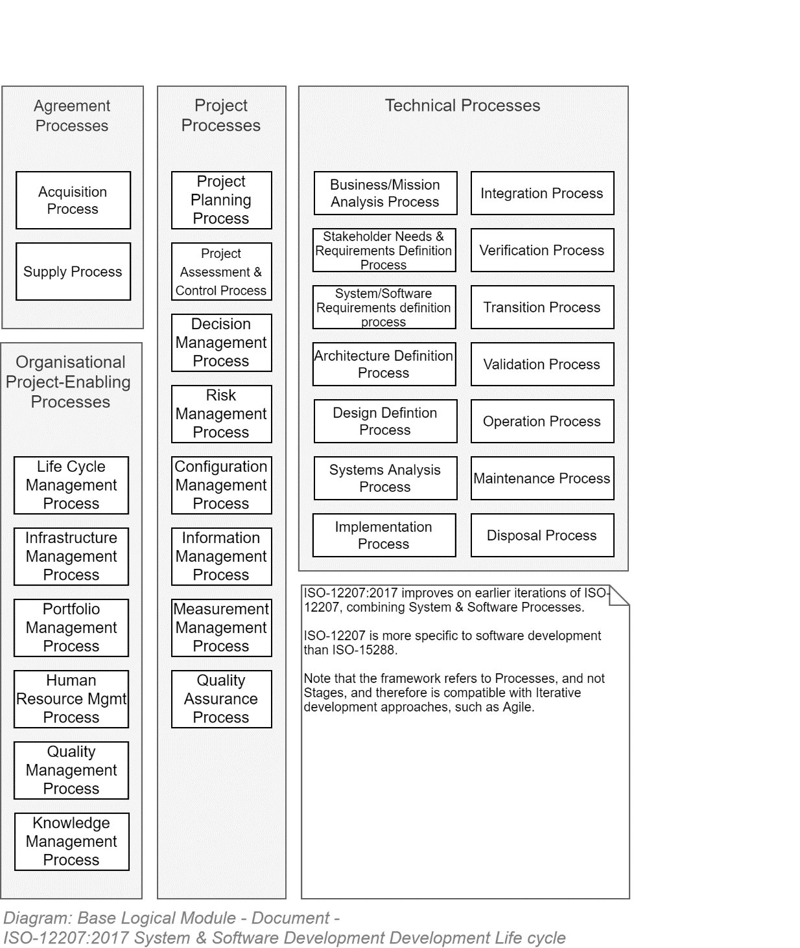

ISO-29110-4-4 & 4-5 Agile & Agile DevOps Life cycle
In spite of any project members who may have had been involved with a delivery process that was called Agile but maybe wasn't, it is a mature delivery methodology that has been around long enough to have been tried in a multitude of conditions, enough so to have warranted its own ISO.
TODO: Add diagram summarising ISO.
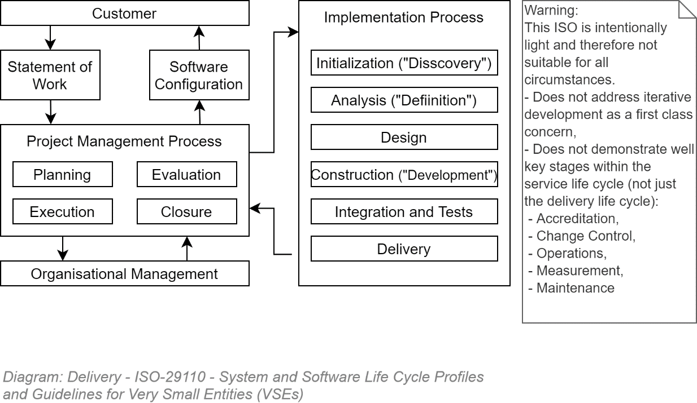

Risks
Projects with an IT component have a high chance of failing.

Risk Register
A risk register collating known risks, their impact, likelihood and available mitigations, and residual risk
A risk registers key purposes include:
- to communicate to all stakeholders – including governance – the overall current likelihood of the project not meeting expectations.
- To allow stakeholders to record areas of concern that require addressing by automation, or failing that, process.
It should be made available to view by all stakeholders and stakeholder group leads to edit.

Categories
Common source of risks come from several internal and external categories:
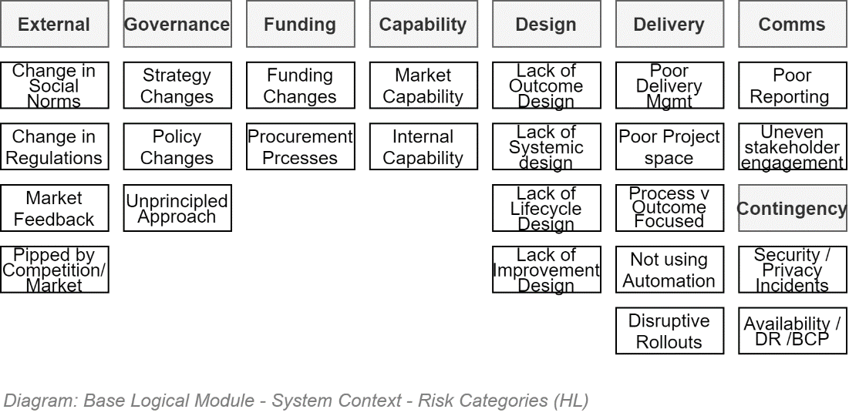

Risks to consider
A list of common risks is available in the Appendices.

Reporting
To provide an insightful overview to governance boards, one must summarise
- whether still on course,
- still progressing at the planned pace or better,
- expecting to have enough resources (time, budget & capabilities) to complete the project
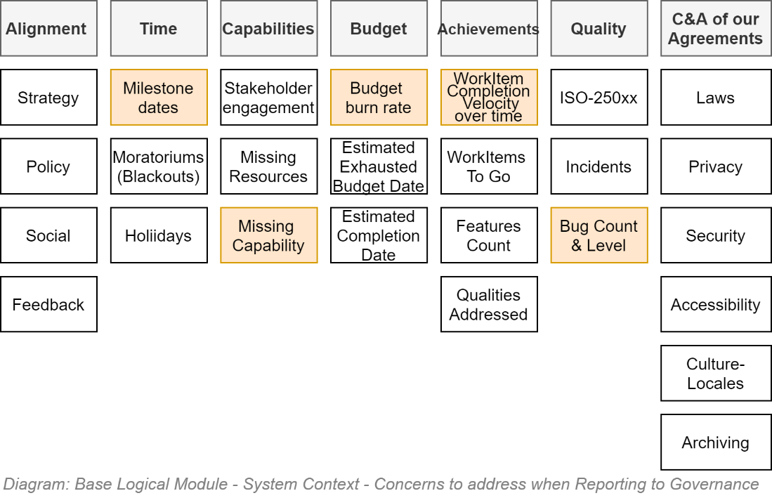
The above information is based upon known schedules, budget burn rate, effort velocity and quality assessments – which can be extracted from an available and kept current WorkItem Management Service.

WorkItem Management
A key aspect of decreasing risk of non-delivering is ensuring that correct and non-ambiguous or contradictory requirements are researched and developed as soon as possible, across all stakeholders, allowing for cohesive design earlier than later.
WorkItems – whether managed in sequential phases, an ad hoc Agile way or recursively in a Agile scrum way, are just blocks of work to progress through the following classic phases of effort:
- Discovery,
- Definition,
- Design,
- Deciding [effort estimation & prioritisation],
- Development
- Delivery [of comms of changes and product itself]
- Supporting [users]
- Operating & Measuring [to report and influence future work effort prioritisation decisions].
- Disestablishment

Waterfall Model versus Agile Model
Whether a sequential heavy design/PoC up-front Waterfall approach or a recursive Agile approach will largely depend on the team’s consensus of what each approach means and implies.
Each has advantages and disadvantages, some of which are -- very broadly -- summarised below:
Waterfalll | Agile
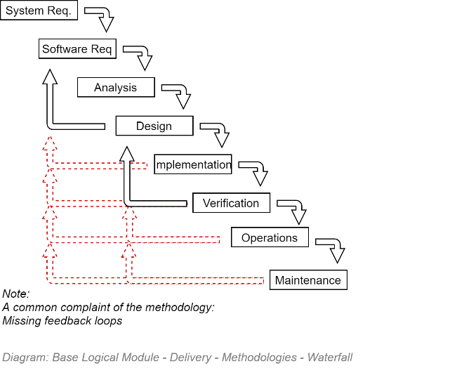 | 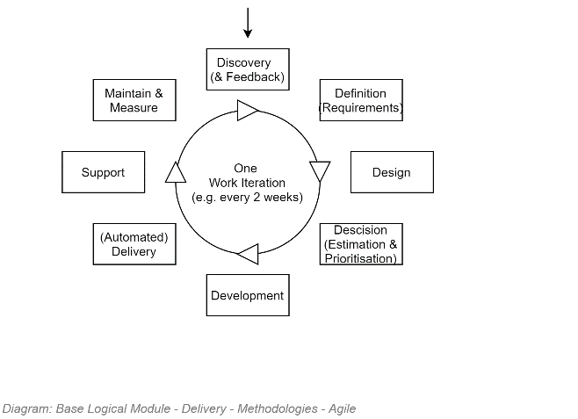
Advantages:  - Emphasis on requirements gathering, definition and design up front reduces uncertainty as to what the team is building.  - A formality of roles and processes can lead to a better understanding of responsibilities.  Considerations:  - Focuses on the delivery of a system – and not the continuous delivery of a service (so changes post go-live are difficult to implement).  Disadvantages:  - One of the few controls a manager has is to reduce scope right from the start.  - The process resists requirement changes.  - Development of complex systems take time. While the world moves on. There is a very high chance that by the time the system is delivered, stakeholders will have expected more, and are dissatisfied. This leads to rework.  Note: almost all waterfall-based projects fail meeting schedule and cost estimates by the time stakeholders are satisfied with the delivery of requirements. | Advantages:  - Releasing often allows for feedback from stakeholders, permitting a responsiveness to redirecting subsequent effort as desired.  - Keeps stakeholders engaged, leading to better quality feedback.  - Managers can manage scope per iterations  Considerations:  - Agile can be used for the initial Delivery phase as well as the subsequent ongoing Service delivery phase (e.g.: 10 years) – but existing poor industry habits still too easily forsake the larger picture to focus on the delivery of a system – and not the continuous delivery of a service (so changes post go-live remain slow to be implemented).  Disadvantages:  - Design will not be finalised before work starts. Due to hype and misunderstandings in the industry, work – and costs -- may start before any substantive discovery, definition or design has been started, when the "Cone of Uncertainty" is large, and Risk is proportional to that.  - Poor understanding of which stakeholders address first (don't start with the UI!!!) can easily lead to excessive requirement and work churn, and therefore cost.  - The requirement for flexibility leads to a confusion of responsibilities.  - Vocal stakeholders can distort the process of collaborative resolution of objectives.

Note:
the Appendices contains a more complete comparison of the two methodologies.

Agile
The most common management approach IT is currently some variation of Agile due to its reputation of removing unnecessary communication & documentation friction, allowing starting early, and repriotising effort upon feedback.

Objective
Key objectives of Agile include:
- allowing capable professionals to perform at pace by minimising unnecessary communication, documentation, and preparation of reports for external review during the development phase,
- Being able to deliver results to end users iteratively at a high cadence to collect feedback which is used to inform and redirect the next iteration’s effort.

Risks
Agile has a well-deserved, but also much-hyped reputation – which it risks not meeting if the following are not understood and managed:
- Capability: the team is not comprised of a high ratio of competent resources that have the experience to self-direct their effort when provided minimal documented guidance (junior and intermediate staff can participate if they are mentored).
- Automation: the use of automation for compilation, deployment and testing is not understood to be essential to keep up with the pace required of the expectation of deploying often to end users for feedback.
- Planning: Agile is intended to allow starting projects while the cone of uncertainty has been narrowed, but not closed -- but cannot solve Adventures. Aiming to deliver an MVP (Minimum Viable Product) without adequate discovery and planning, expecting the team to pivot in any direction potentially at every sprint meeting ensures only the delivery of an MVP of the Missing Valuable Planning type.
- Documentation: Agile is a methodology for the delivery phase of a service, less so for the full-service lifecycle. Documentation is required to be developed for other users. Just less, as well as kept current within the Project Wiki rather than getting stale in reviewed Word documents.
- Deliverables: the largest risk to Agile projects is the common misconception of what it means to get something new in front of users at every iteration.
Warning:
Agile does not mean system development must be begun immediately at the expense of planning in order to get something in front of stakeholders.
The first iterations are used to set up an online project collaboration space, where project documentation -- including this manual -- are available to all stakeholders. This project space is the first service lifetime deliverable.
The next iterations should be a used to develop a bare-bones, “just-enough”, achievable, technical design for review and consensus by appropriate stakeholders before starting. Such a technical design roadmap, although not the final information service itself, is also a deliverable.
The next iteration(s) are used to focus on developing an automated test and delivery pipeline. This too is a deliverable.
Only after the above deliverables are well on their way, start iteratively delivering the next deliverable -- the information service itself.
Finally, when the backend service is starting to expose usable APIs, start developing the final deliverable – the service client user interface.
Important:
Whatever you do, don’t start from the interface (that’s akin to designing a car starting with the panelling, expecting it to be a good source of information on which to design the internal engine).

Application Lifecycle Management Service (AML) Suite
An ALM is a suite of integrated services commonly used on software projects.
The Code Management Service relies on the Work Item Service to make it easy to navigate from code directly back to the work item that commissioned it. The build pipeline relies on the code management service to retrieve the code it needs to compile, and the delivery pipeline relies on the build pipeline to retrieve compiled artefacts to deploy.
Some ALM suites also provide tools to facilitate old-school manual testing processes.

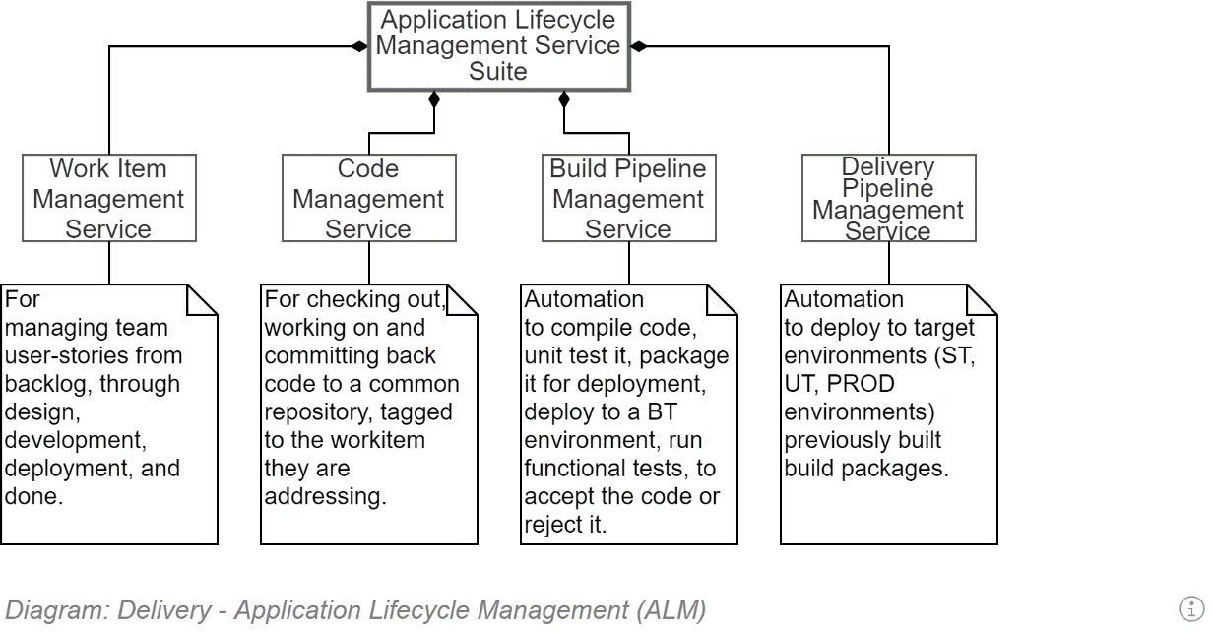

Work Item Management Service
To manage Desires, Requirements, Epics, Features, User Stories, Tasks – and manage their conversion into deliverables, a WorkItem Management Service is required.
Many such services exist as stand-alone products (Trello), some of which can be automatically updated by code repository activities (e.g.: JIRA).
High value Work Item Management Services have most or all of the following characteristics:
- are integrated with other development services (code repository, build and deployment pipeline, etc.) by default,
- Allow work items to be accessible internally and externally (by vendors, consultants and collaborators) on any device, as well as being printed.
- Work items can be viewed as Kanban staged boards or lists, preferably both approaches allowing filtering/sorting and printing as needed.
- are viewable by users outside the production team, can accept Users submitting Requests as unformatted Desires/Issues.
- Can report on velocity at which work items are completed -- filtered by project, group and individual -- to inform the estimation of durations of future work items.
- Can create dependencies between work items to inform prioritisation and sequencing of tasks.

Agile WorkItems (Epics, Features, User Stories).

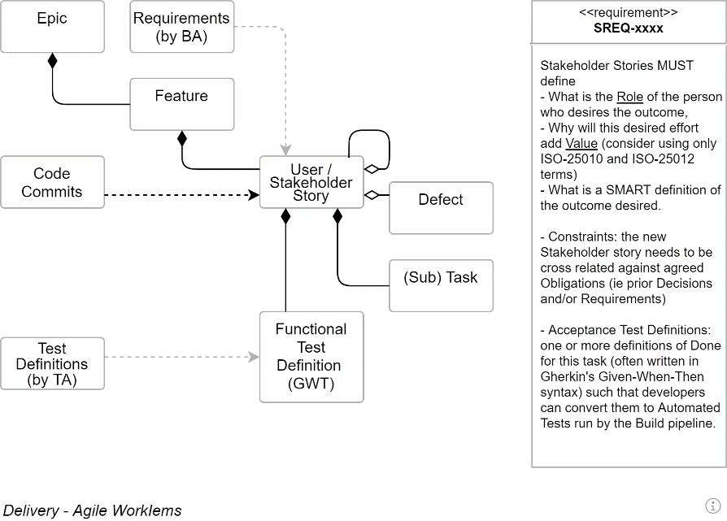

EPICs
Epics, as the name suggests, are large conceptual divisions of the service that is to be delivered.

Warning:
It’s a common error for developers to think of Epics as very large sets of User Stories/Tasks. Whereas they’re not – they’re more of a Classification system of ongoing key concepts needed to be worked on over many releases.

Features
Whereas Epics are never-ending – or at least exceptionally long -- workstreams, Feature [Sets] are large but finite clumps of User Stories, focused on specific functionality, probably not completable within one iteration/sprint.

User Stories
The raw basics of a User Stories – it's title -- is a 3-part statement expressing a Desire, written from the perspective of a stakeholder role willing to sponsor it, expressed as a valuable outcome.
The default formats used are either
- As a <stakeholder>, I would like <feature>, So that <outcome>
- For <1+ valued objectives>, As a <sponsor>, I would like <feature>
Both approaches have merit – the first expresses the action the role will be able to accomplish – the second expresses an expected Value making it easier to evaluate prioritisation of tasks.
The project may adopt merge of the two main formats:
For <1+ value objectives>, As a <sponsor>, I desire <feature> So that <outcome>
Tip:
An interesting aside is that whereas an Epic is as defined above, a Journey comes from the French word “journée” (day) -- as in a guild member’s day’s work. A User Story should not take a professional Journeyman (as opposed to the modern-day equivalent of an Apprentice) longer than a journée, during which several sub-Tasks will be accomplished.

Stakeholder Story Attributes
The following is a diagram of some of the attributes a well developed Stakeholder story has.
Valuable stakeholder stories reduce misunderstandings, discussions and risk to the project, while improving group cohesion around well designed, communicated and agreed outcomes.
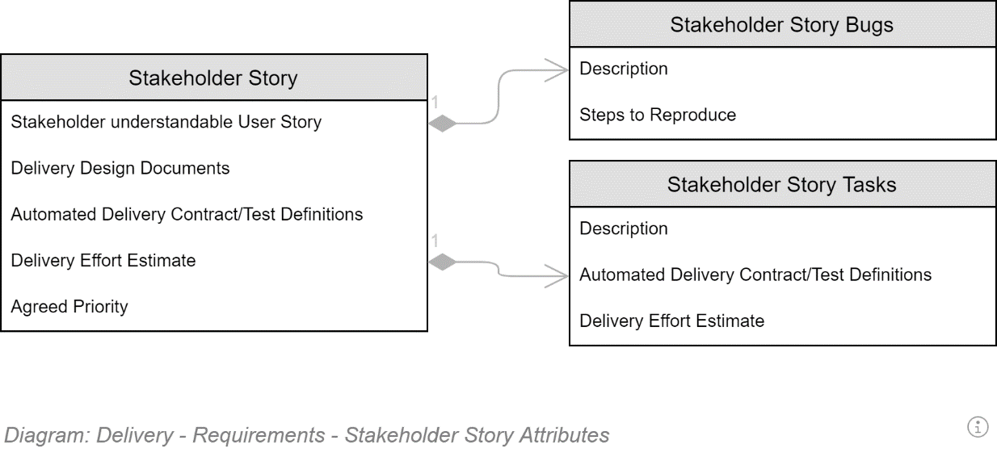

Documentation Management Service
A deliverable from a software delivery project is documentation to permit operations, maintenance, improvement over its service lifetime.
A hierarchically organised wiki is the most appropriate documentation tool.
Note:
The irony is not lost on me: the information within this description document should be available in a wiki, rather than as only available within an archaic desktop publishing tool artefact.

Source Code Management Service
TODO

Build & Deployment Pipeline
TODO

Related Documents

Capability
The best plans can be undone by lack of capability.

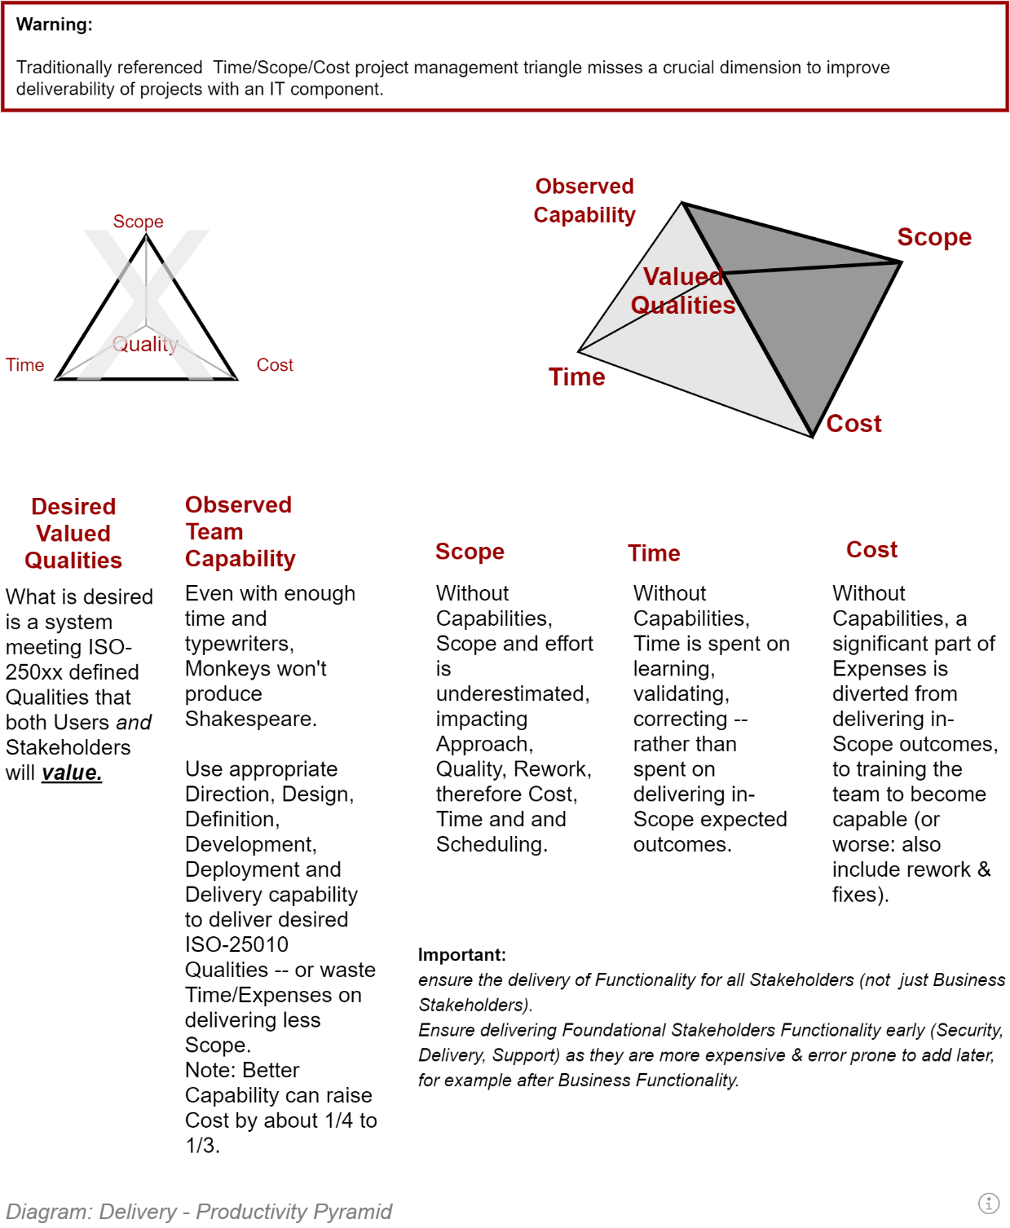

Deliverables
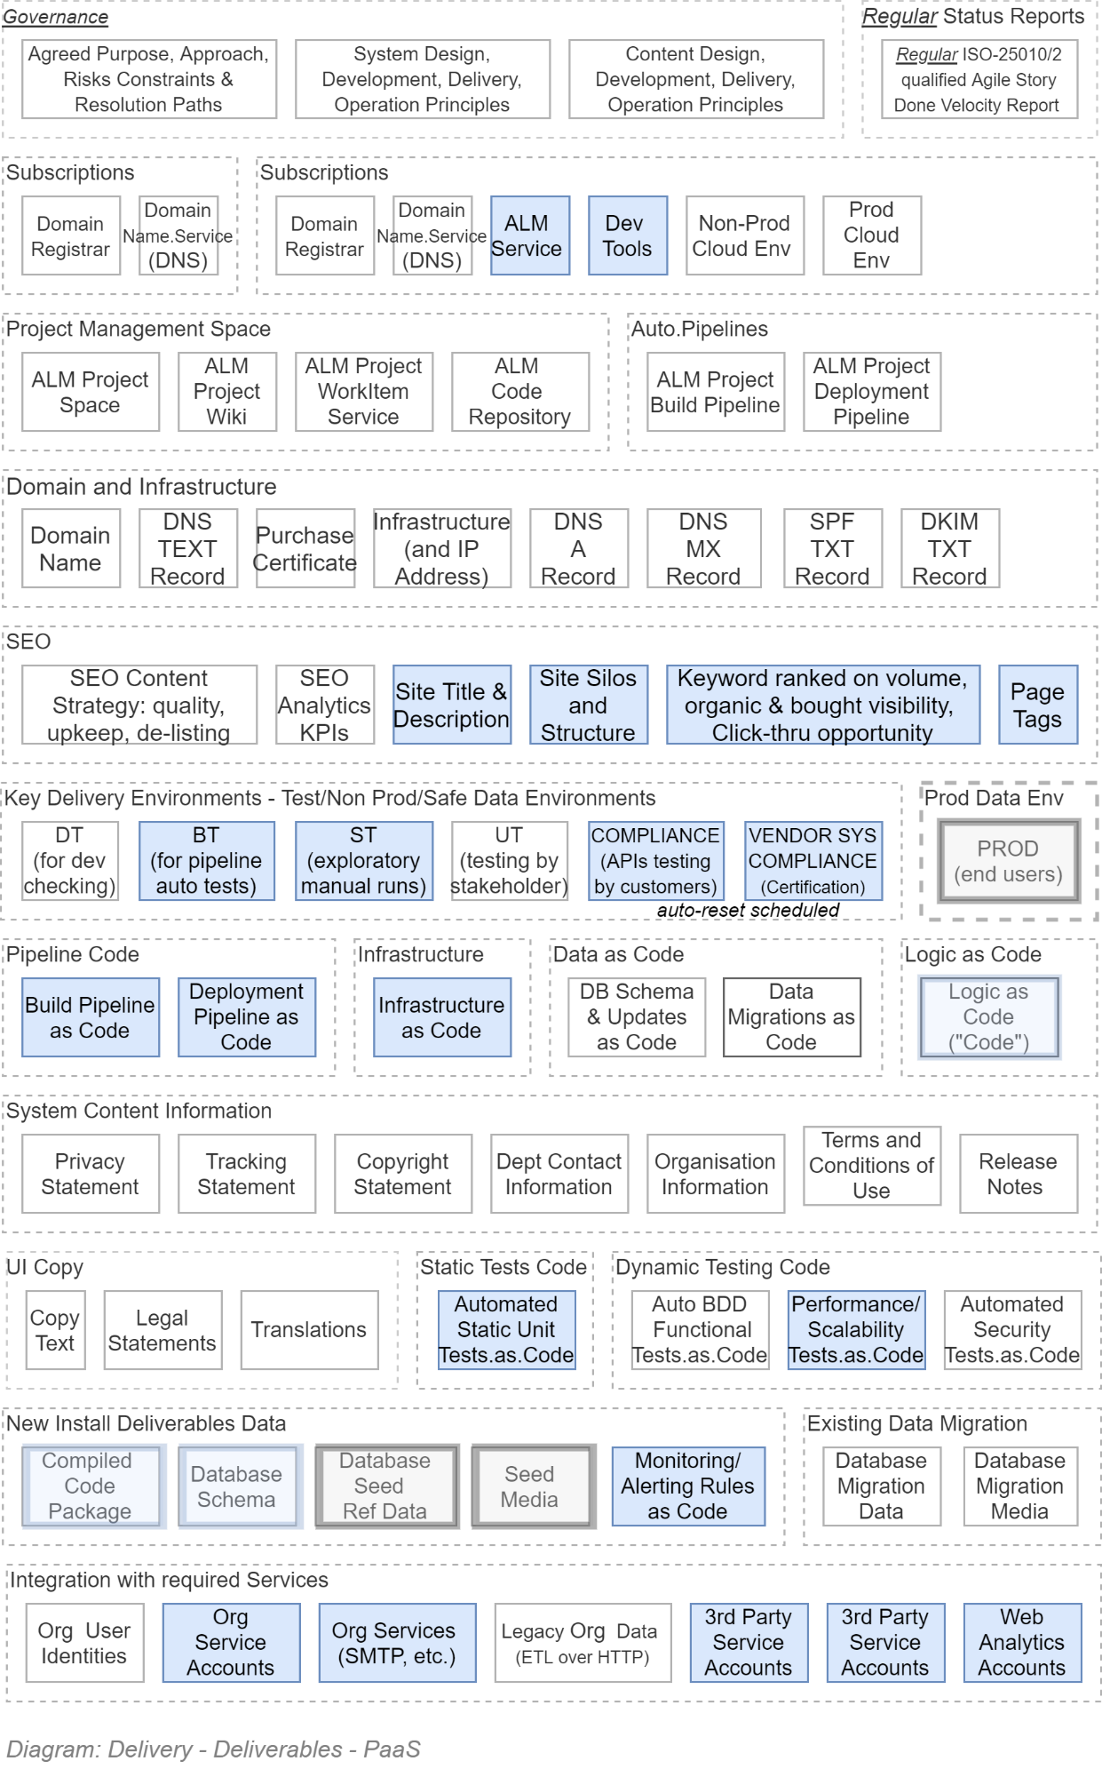
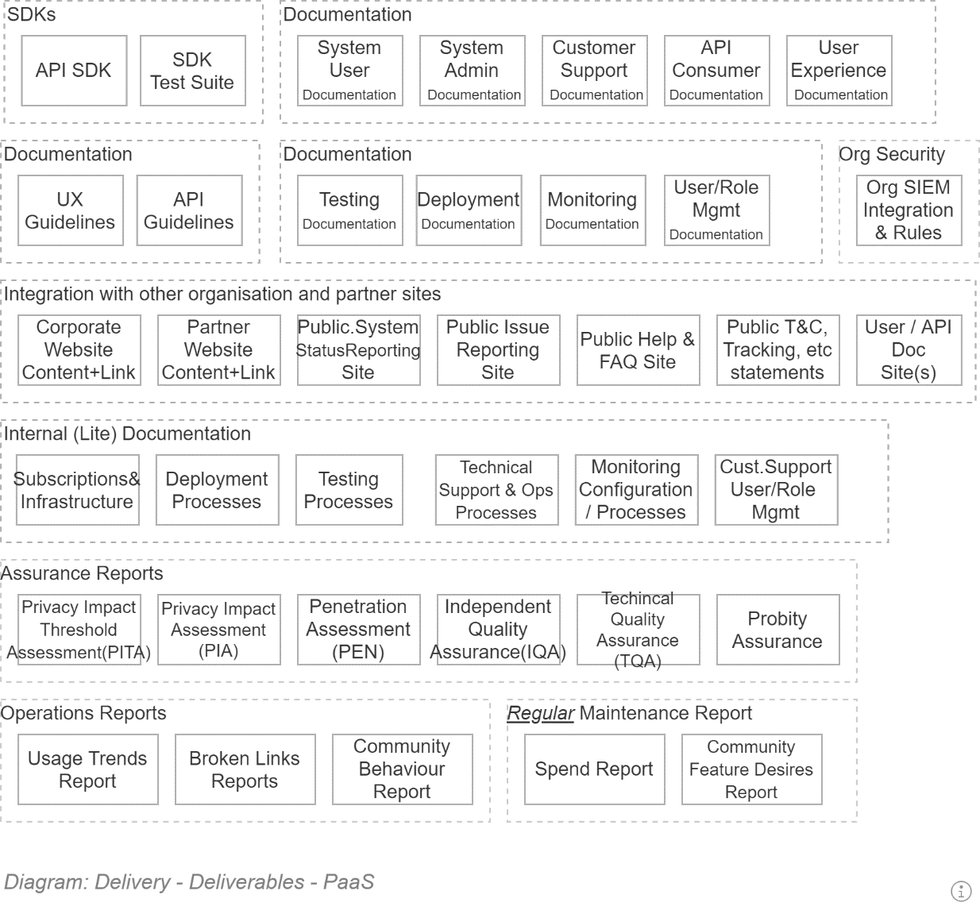

Service Data Storage Development View

Section Synopsis

Governance

Self-Governance

Technologies
Several technologies are used to persist data for the system:
- A blob storage to store images.
- A relational database to store relational data.
- A document database to store semi-structured non-relational data.
- An ORM to manage interactions with the relational database.
- An automated workflow to manage the deployment of schema changes and ensuing migration of data.

Object/Relational Mapping (ORM)
Requirement
The solution must be developed using an OO based ORM service to manage CRUS operations.
The rationale is recognising the limited local market availability of developers capable of consistently & quickly developing and maintaining optimised SQL operations.

.NET Core / Azure based development:
The ORM must be capable of updating database schemas on demand (note that Microsoft Entity Framework has this capability, marketed as “Code First Migrations”).

Security

Service Account
The service Accounts that are registered in the service database are:
- The deployment pipeline’s service account, to create databases, update schemas, seed reference data.
- The information system’s service account, for its ORM to manage the creation of databases, updating of schemas and seeding reference data as required.

Connection Strings
Within an Azure environment, the connection strings MUST not include the service account’s name or password in cleartext. Instead, use Microsoft Secure Identity (MSI) or an equivalent password-less service account approach.

Security in Transit
The connection between a service and its datastore must be secured. This is especially true when using Cloud provider databases.

Requirement:
If using SQL Server, the connection string MUST include the following flags:
- IntegratedSecurity=true;
- -
- Encrypt
In addition, ctruel;
In addition, cTrustServerCertificate
In addition, consider the use of the hostNameInCertificate attribute

Note:
As of .NET4.5 When TrustServerCertificate=false and Encrypt=true the serverAs of .NET4.5 When TrustServerCertificate=false and Encrypt=true the serverAs of .NET4.5 When TrustServerCertificate=false and Encrypt=true the server name in a SQL server Cert MUST match the server name or IP in the connection string.

Security at Rest

Requirement:
Towards Security/Confidentiality objectives, the Database must be persisted on an encrypted hard drive.

Requirement:
Towards Security/Confidentiality objectives, the database must be encrypted.
The rationale is such that if the data centre were broken into, a stolen hard drive device would still be difficult to read – and if the database were downloaded, it would remain unreadable without a key.

Requirement:
Towards Security/Confidentiality and Privacy objectives, the database columns used to persist sensitive data (e.g.: PII) must be encrypted.

Database Backups and Restorations

Warning:
The loss of user data due to a database being unable to be restored has the potential of causing irreparable damage to an organisation’s reputation. Therefore, Data Backups and Restoration must not be afterthoughts – their automated execution must be an integral part of the service design.
In addition to the databases being backed-up and restorable, they backups must be handled as securely as production data databases.
Requirement:
Backups MUST be encrypted.
The Rationale is that backups are still production data – only very slightly stale.

Requirement:
Full backups and Incremental backups MUST be performed at a configurable cadence – generally a full backup every day and incremental backups every 15 minutes, or shorter, depending on the service.
The Rationale is that accidents happen, and it is important to minimise the data loss between the last backup and error condition, in order to meet strict Restoration Point Objectives (RPO).

Requirement:
Backups MUST be kept for a minimum of 31 days.
The Rationale is being able to provide Point-In-Time-Recovery (PITR) as needed to meet Restoration Point Objectives (RPO).
In addition to meeting requirements specific to the safety of the database backup, the backup location has to be carefully chosen.
Requirement:
Backups MUST be persisted to another resource group.
The rationale is ensuring the database backup is not deleted if the system resource group is deleted, which should relatively regularly to ensure the infrastructure as code instructions are still correct and the environment can be quickly rebuilt as needed to meet DR requirements.The rationale is ensuring the database backup is not deleted if the system resource group is deleted, which should relatively regularly to ensure the infrastructure as code instructions are still correct and the environment can be quickly rebuilt as needed to meet DR requirements.The rationale is ensuring the database backup is not deleted if the system resource group is deleted, which should relatively regularly to ensure the infrastructure as code instructions are still correct and the environment can be quickly rebuilt as needed to meet DR requirements.

XXXX: TODO

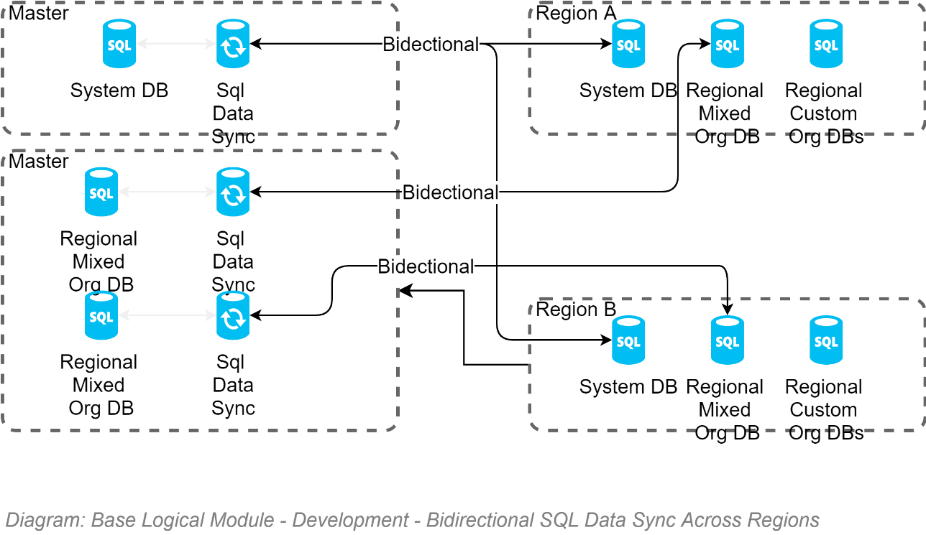

Service Development View

Section Synopsis

Governance

Self-Governance
Developers are provided a governance framework to develop at pace, without resorting to external Governance decisions.
Developers – as a group -- must self-direct their work using the guiding Principles that impact the solution.

Principled Design
The Principles that the architect must be guided by and adhere to where possible and appropriate include:
- AoG obligations:
  - NZ Privacy Principles
  - NZ Digital Standards Principles
  - NZ Digital Service Principles
  - NZ Data and Information Management Principles
- This organisations obligations:
  - Architecture Principles
  - Integration Principles
These principles are outlined in an earlier section, as well as the Appendices.

Principled Development
The number of principles that a developer must adhere to are fewer:
- Principled Design First: Developers must understand that the system designer is constrained to be guided by the above principles and not make changes to designs without consulting the system designer.
- Automated Delivery Pipeline First: Developers must not develop system functionality before developing the automated delivery pipeline within the project’s ALM.
- Automated Test First: Developers must not develop new functionality before developing the automated tests to demonstrate their correct functioning.
- The Project Principles: the developer must adhere to the following previously listed Principles:
  - Pipeline First
  - Secure First: all cross device connection channels are encrypted.
  - Automated Test First: develop tests first, as proofs of work & obligations met. Automate them in the
  - Web Interface API First
  - Multiple Channels First
  - Universal User First
  - Smallest Visual Interface First
  - Succinct, Summarized, Actionable, Forgiving, Views First
  - Forgiving Behaviour First
  - YAGNI – as long as it is not used to defer required work.

Technical Decision Registry
Deviations from the above guiding Principles should be very rare (or else the Principles need to be updated) and must be recorded in a Technical Decision Registry to inform future designers and developers.
Tip:
It is recommended to make the Technical Decision Registry an easily accessible section of the project ALM’s Wiki.
Keep in mind that it may need to be sometimes formatted to print and present to Governance boards.

Standards
We facilitate interoperability Quality objectives we are mandated to use available international standards before optionally designing new ones.
As per the NZ Digital Standards:
- “Standards compliance is consistently applied. Agencies are obliged to responsibly self-regulate standards compliance. Where policy demands, an agency or a supplier must comply with a standard and provide evidence to verify or certify compliance.”
- “Adopting international standards should be first. If one is not suitable, consider a NZ profile of an international standard, rather than developing local NZ or NZ government standards.”
The following are core standards expected to be used within any and all systems used within this organisation.
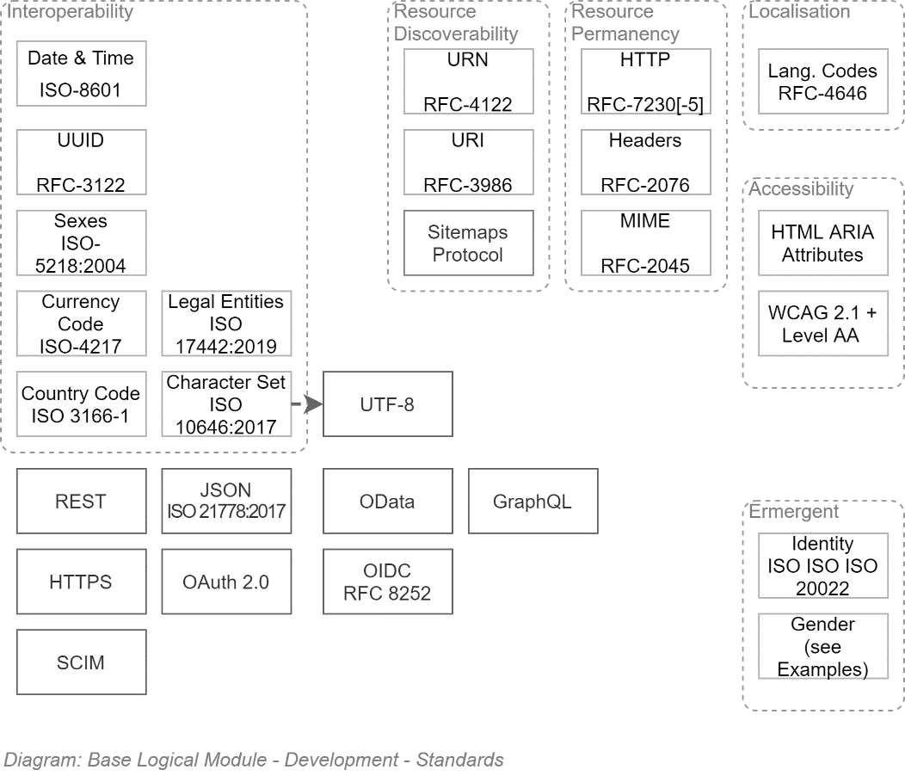
The above is less difficult that it at first appear. At a high level, the gist of above diagram simply translates to:
- Use UUIDs for record Id’s.
- Use Client or Application Tier (not Data storage Tier Databases !) generated UUIDs for IDs
- Persist values using ISO standards.
Avoid home brew solutions for values (e.g.: "NZ". Or "N.Z." Or "New Zealand" all look like reasonable decisions, until systems need to synchronize and match against 3 different possible values)
- Persist text without stripping macrons, umlauts, etc. Accept international characters.
- UTF-8 is the standard for web pages now. Don't use anything else.
- Use the most precise MIME definition available (JSON is not TEXT, for example).
- Use OIDC to authenticate Users. Use OAuth to authorise systems.
- Use OData over REST over HTTPS for APIs. GraphQL. Is an acceptable duplication of OData (although not as a replacement).
- And ensure Support staff can provision lots of users and groups, using SCIM.
- Use international standards to make UIs accessible to visually impaired users.
Really not difficult at all once you get into it (SCIM probably can be done just by buying a library to help out).

Protocols

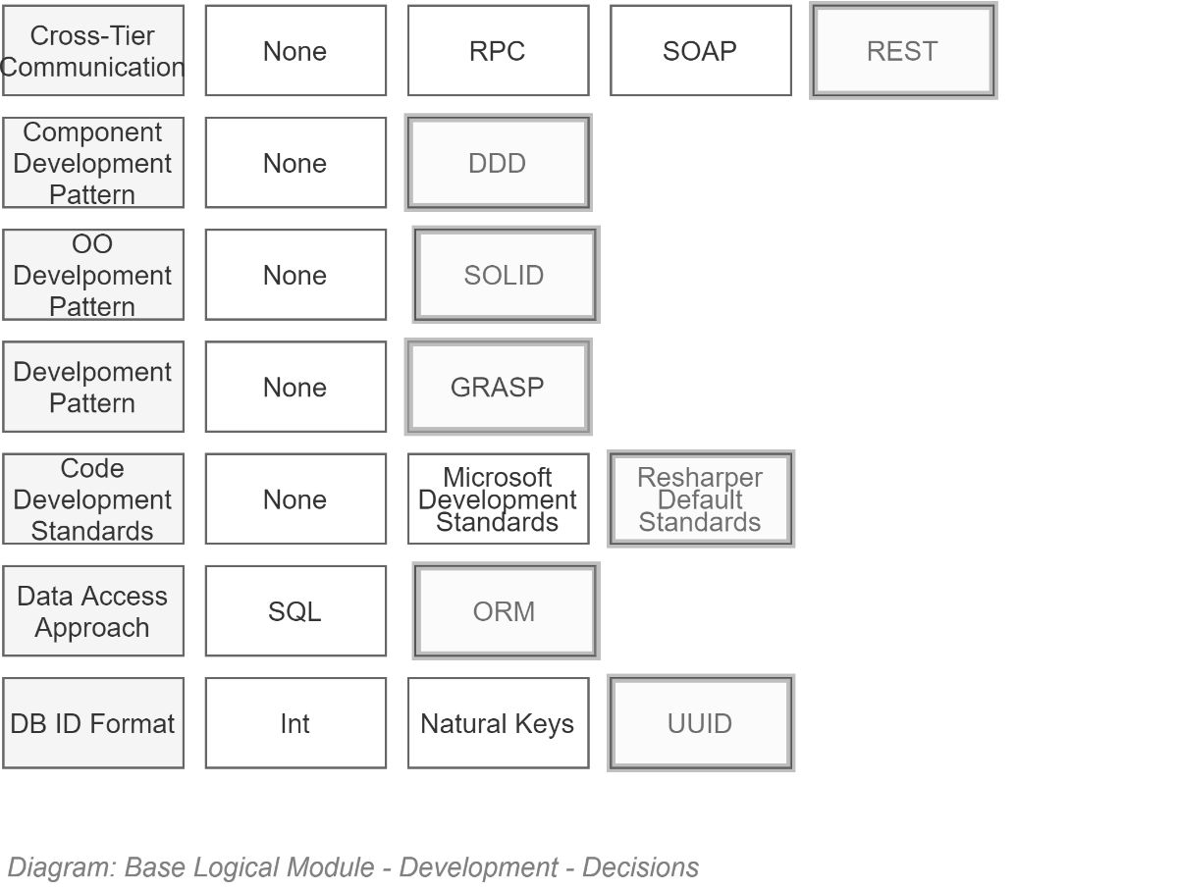

Development Technologies
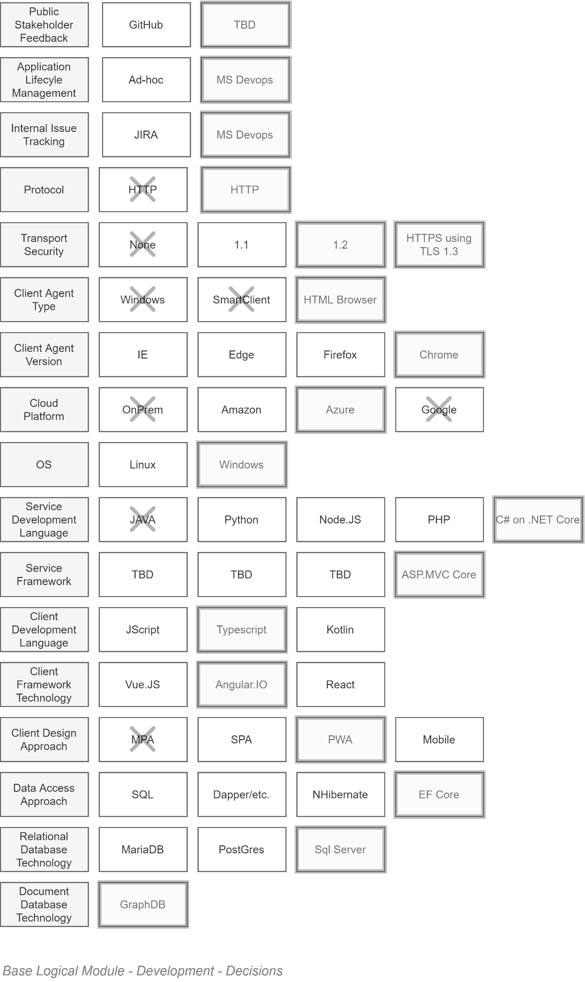
TODO: Fix Diagram (HTTP/HTTP…)
Organised by deployment Tier, the above is as follows:
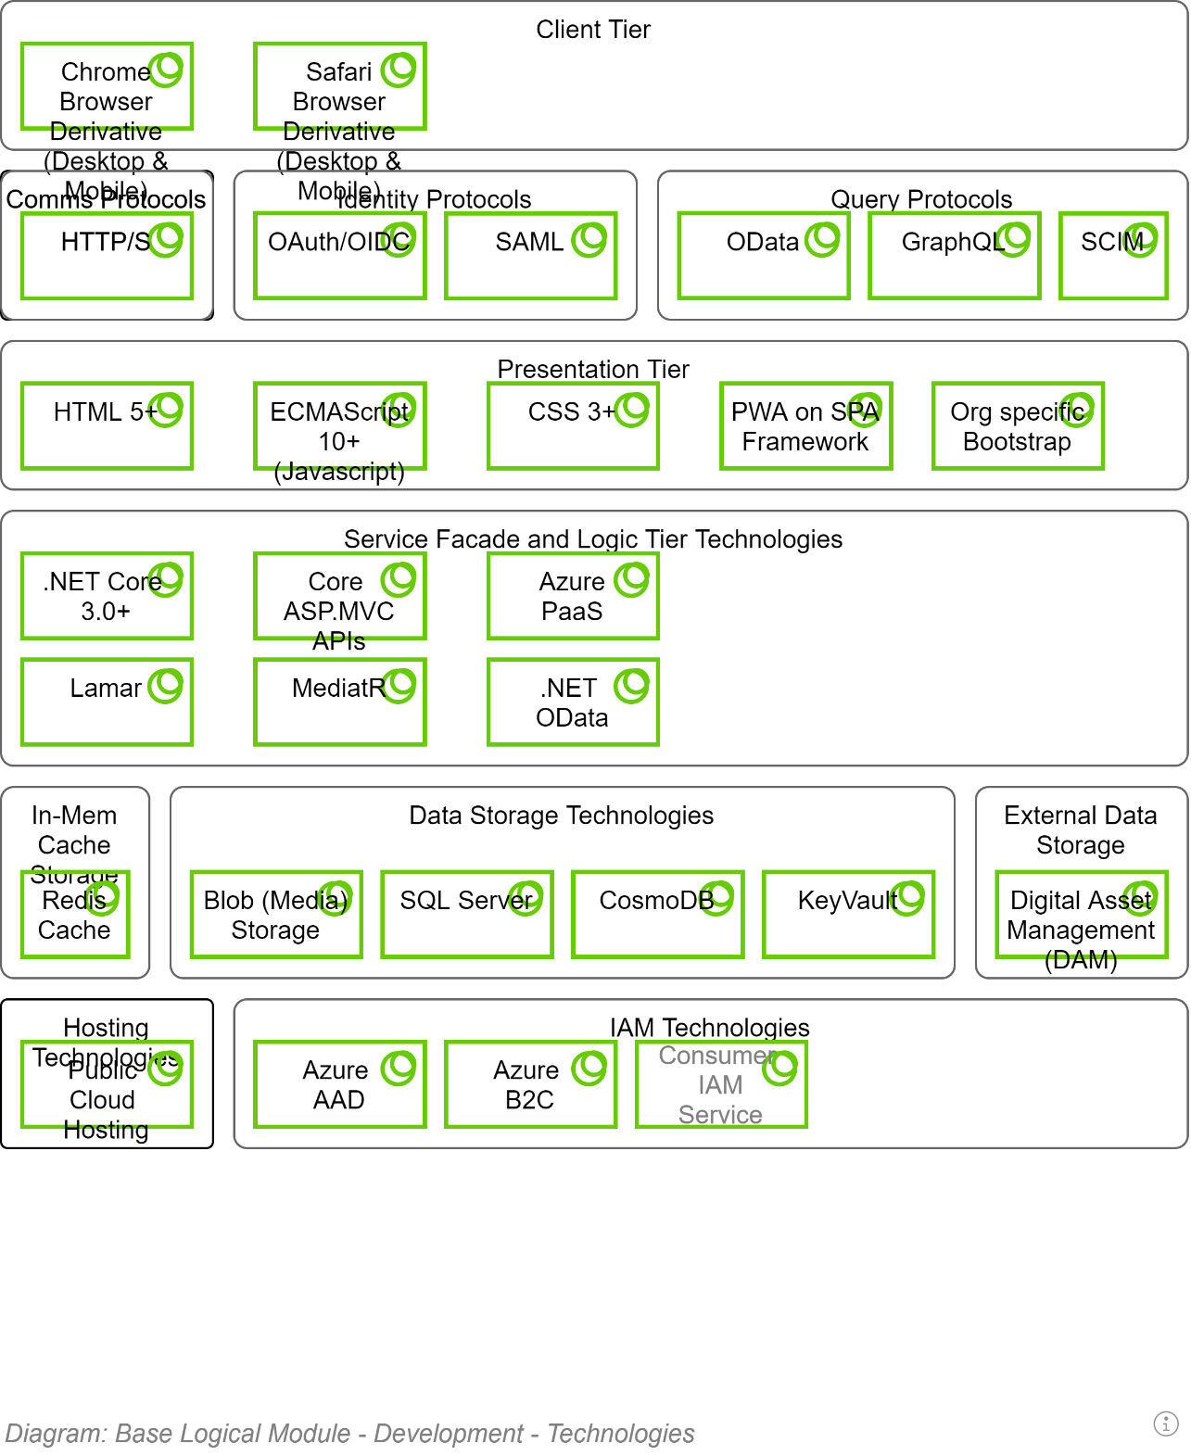

Maintenance Latest Version as Standard BAU
For maintainability, interoperability and security reasons the system must be maintained to update to the latest version of each standard when 20% of the market is using it, or within a year – whichever is shortest.
These updates must be a BAU operation, and not require a request from project stakeholders to initiate the work.

Constraints

Regulations
TODO

Principles
TODO

Best Practices

General
Where not specifically defined in this section, Developers are constrained to use current Best Practices – and not current Market Practices.

Test Driven
Developers MUST follow an automated Test-Driven Development process.
The following is an example workflow:
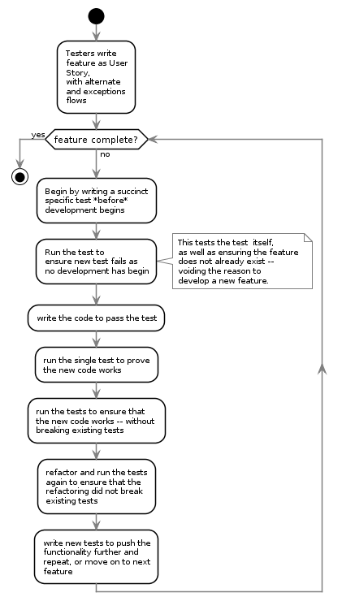

Documented
Source code must be documented to facilitate reviews as well as decrease the risk of the market being unable to deliver capable maintenance specialists to take over and continue the work.
Note
A long-running debate has existed in the development world, implying that code comments within code is not required if the code is clean and self-describing. The argument is idealistic and simply wrong. Code is written to communicate with computers. Comments are written to communicate with humans. You would not say that a book written in French, if written well enough, should not require assistance to allow an English person who is not 100% fluent to read it). Secondly, there are many types and levels of stakeholders in a project, not all access the code. Produce documentation of what is going on, elsewhere.

Loose Coupling, High Cohesion
Where possible, use SOLID development patterns – specifically Liskov's Substitution and Dependency Inversion design principles.
Note:
In C#, this is implementable as:
- Using a class' constructor to inject– typed as Interfaces -- any service dependencies needed.

Real-time Notification over Delayed Batch notification
Where applicable, prefer real-time notification messages between systems of changes, over the use of delayed scheduled updates (i.e., no reliance on after hour “fat” ETL operations).
Note:
Use Queued Command patterns to process batch or CPU costly operations as close to real-time while limiting the impact on more prosaic transactional operations.

Protocols

Development Patterns
Distributed Version Control Service
The use of a distributed Version control system is a key productivity driver.
Competent ALM Services – as referenced in the Delivery View –providing

Use of
Continuous Delivery Service

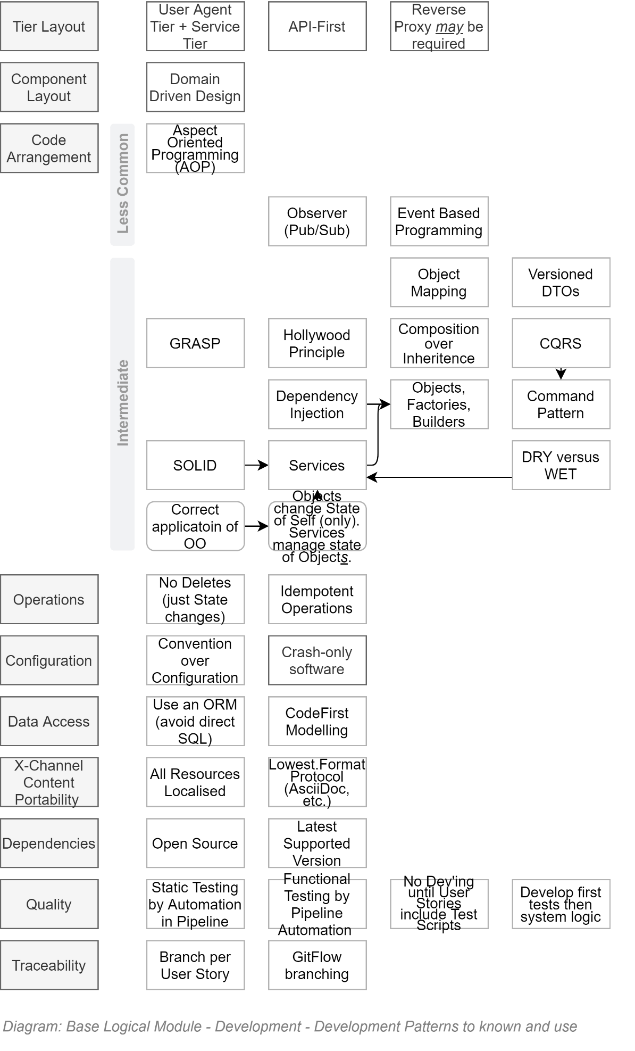

Pull-Requests
The Agile Manifesto was put together by top-notch developers. Even for them – and certainly for everyone else -- review of code submissions is a valuable process to protect the code base.
Pull-Requests for Review of changes must be issued before branches are merged into target branches.
Mature code integration pipelines can be configured to automate reviews of code formatting, code complexity, unit testing, functional testing, etc – basically taking care of the minutia -- before the submitted code is reviewed by a human team member for opportunities to optimise the code.
Note:
if the continuous pipeline has been configured to automate the review of format, complexity, unit testing, and functional testing, review by a human can often be skipped – most apps are not required to be race cars (they really just need to be functionally correct, while meeting quality expectations).

Verified Code Branch Integration

The Version Control Service employed to deliver the solution performs *Continuous Integration* activities and verifies submitted code feature branches before integrating the code with the protected `master` branch.
If the Version Control Service rejects the code due to it failing tests -- or a `Pull Request` reviewer (see elsewhere in this View) has manually rejected the submission -- the developer has to fix it and try again before the Version Control Service will allow the submitted feature branch to be integrated with the protected `master` branch:

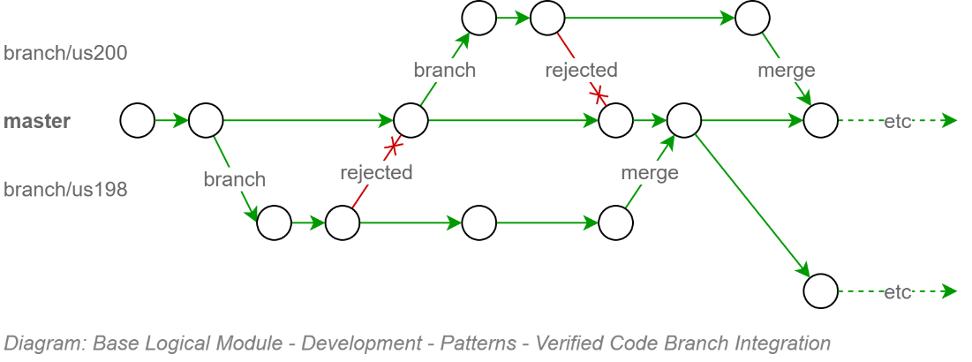
This upfront effort configuring the continuous integration pipeline to protect the code base from getting polluting, protects other developers from downloading poor code and working around it – only to have to remove the work arounds when the original poor code is fixed.
Tip:
This is no different than the kinds of real-world safeguards that would be put in place if we were talking about a communal water reservoir, with everyone tasked with filling it up, and everyone drinking from it. Unless catching typhoid was an objective.

Automated Tests
Static Tests can be performed on the source code itself, or the components created by compiling the source code. Dynamic tests can only be applied once the components have been deployed to a target environment.
The following categories are recommended for testing by automation.
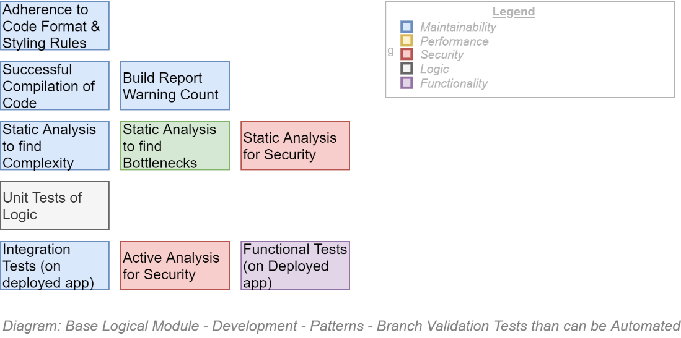
The project is not expected to automate every test possible before beginning to develop the information system – but the project manager and dev team lead are expected to put aside resource time to implement in an ongoing continuous manner till they are completed.
Note:
The importance of these automated tests are two-fold:
- ensuring the quality of code during the main upfront development phase,
- putting in place before handover to different (support) developers the automated safeguards required to ensure the initial quality of the product does not degrade over service’s whole service lifecycle duration.

Component Design Patterns
Domain Integration (DI) Service Design
Domain Integration is the recognition that Services are the composite result of integrating multiple Domains around their unique information.

BITS
A Business IT Service, in its simplest form, can be envisaged as the merging of two domains:
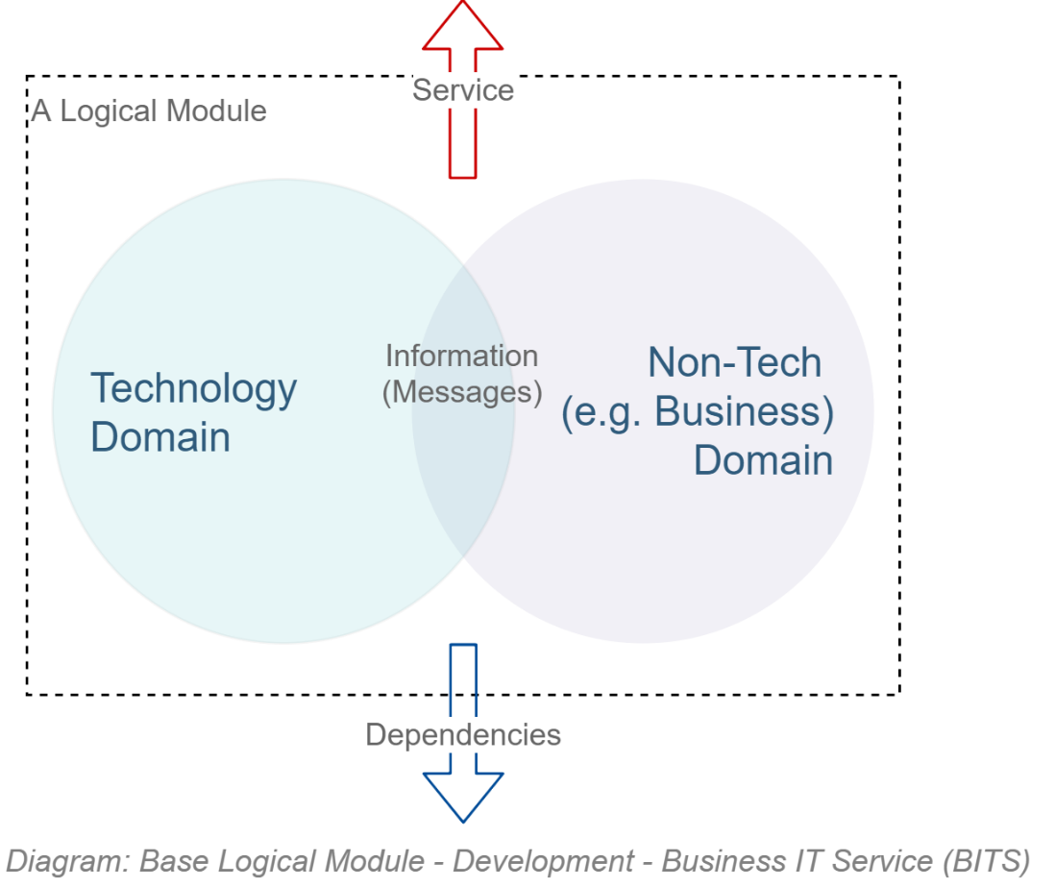
Reality is a little more complex: the actual number of domains involved in an IT product is higher:
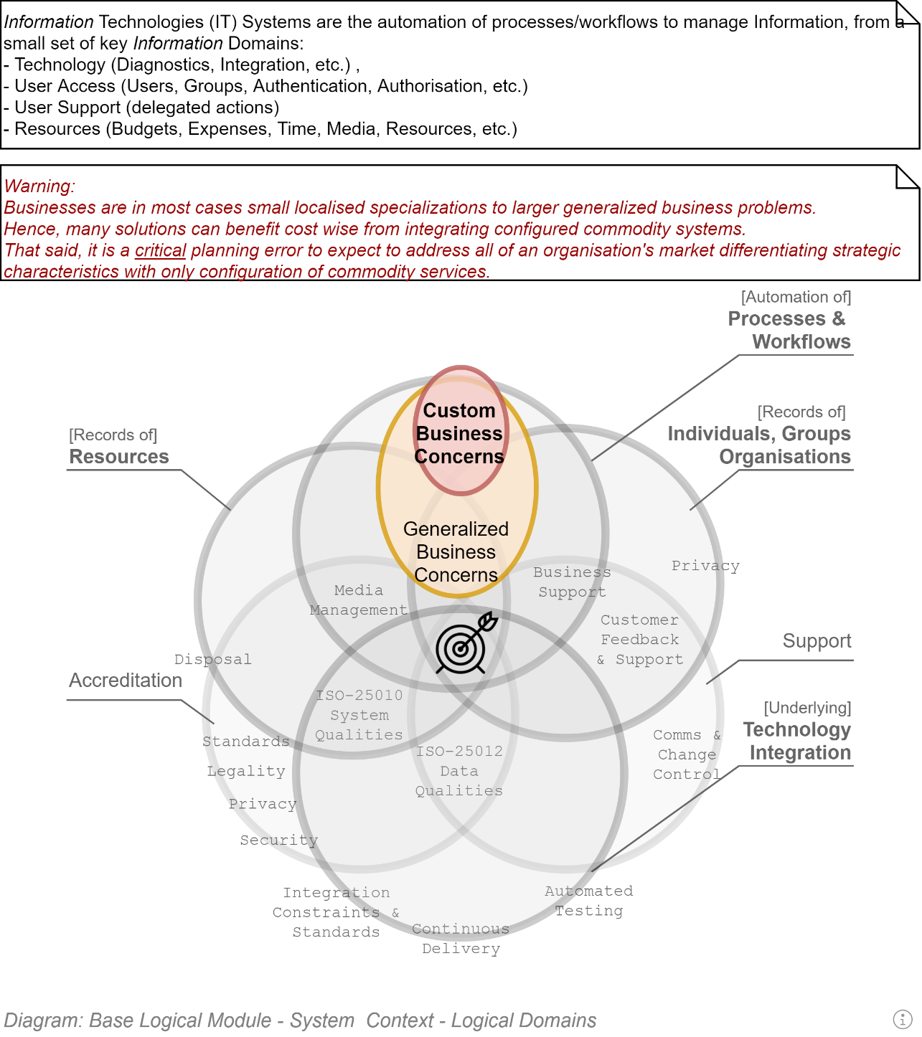
But that just means a couple more Logical Modules.

Domain Driven Development
Domain Driven Development is a well-established and successful approach to developing OO systems.
It recognises that there are disparate domains that MUST be kept distinct -- to not become one big unmanageable indistinct mess of logic across multiple domains – and handle the orchestration between them in a thin way.
Note:
Domain Driven Design is more holistic than the above short introduction to it and is well worth reading Eric Evan’s seminal work on the matter.

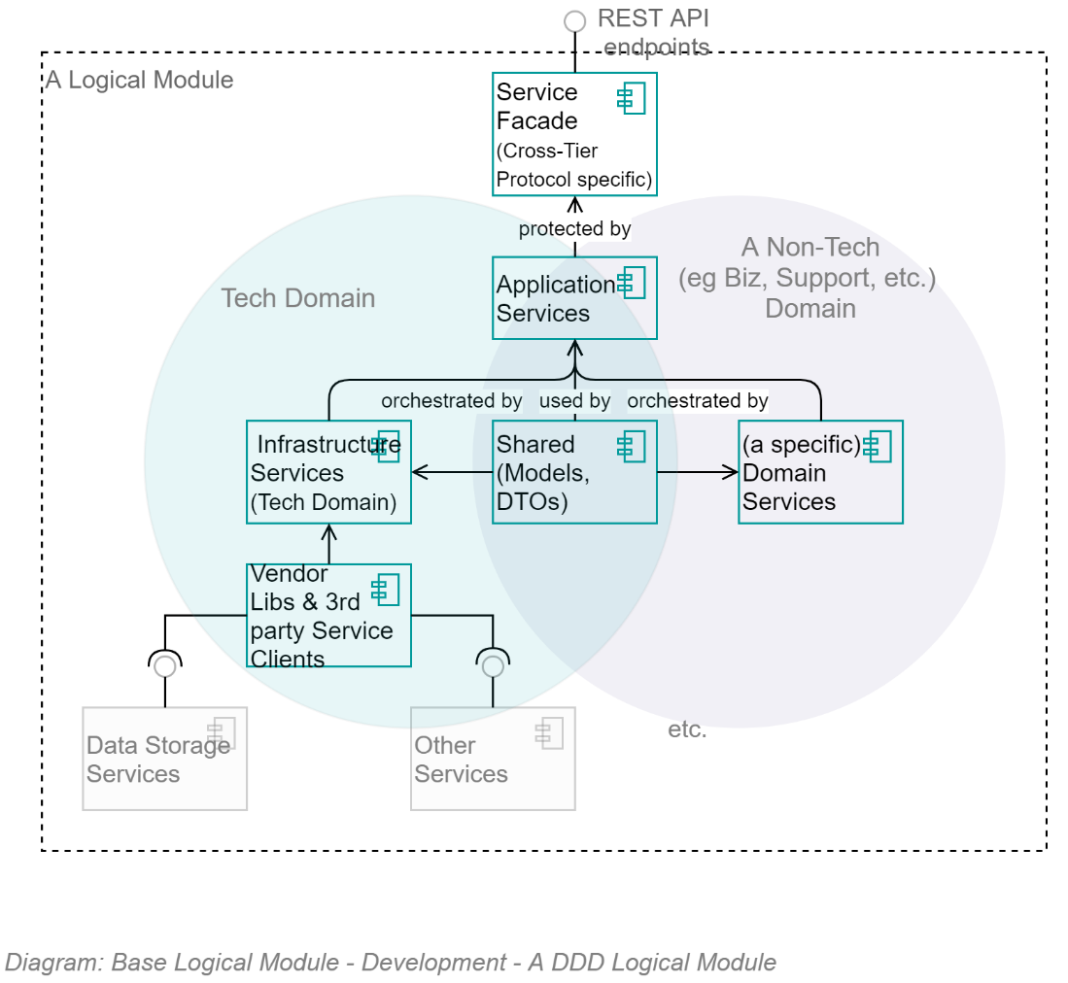
The above diagram demonstrates that, as per Domain Driven Development component composition pattern, all logical Modules are composed of 5 key parts:
- Infrastructure Services:
a set of infrastructure/technology domain services.
Note that a key benefit of the Infrastructure Assembly isolates the rest of the application from dependencies on 3rd party open source and vendor libraries by providing system specific wrappers that provided simplified, app-specific methods, returning to the rest of the system app-Specific messages.
- [Non-Infrastructure] Domain Services:
A set of (business or other non-infrastructure) domain services
- Application Services:
A set of Application Service over both of them, orchestrating calls between the two distinct domains, while keeping them separated
- Shared Entities/Messages:
A shared set of messages/entities that all three sets of services can be passed between them.
- Service Facade Controllers & DTOs:
A service facade to expose the Application Services to external users as APIs and DTOs.
The same information – this time in a straightforward classic UML Component diagram -- is as follows:

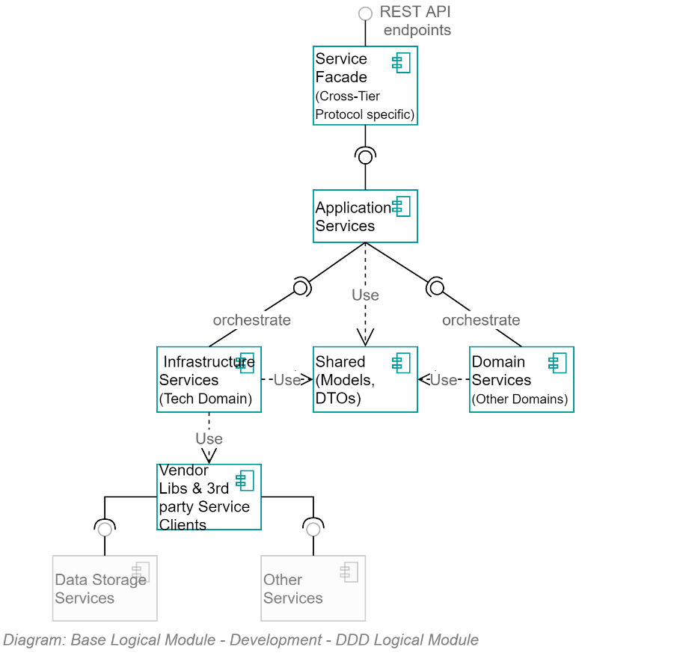

Object Oriented Development
DDD builds upon and therefore has a dependency on developers applying correct Object Oriented (OO) development patterns.
Object-Oriented development means, in essence two things:
Object definitions are used to create Instances which have public and/or private properties and optional methods to manage their own properties. Objects do not invoke external services or change the properties of other Objects.
Vice versa, stateless singleton instances of Services definitions are used to manage multiple other objects (think of them as specialised helper classes).
This clarity of each object type’s role is easily demonstratable as follows:
- A bank account object has a read-only Balance property and two methods: AddAmount(amount), RemoveAmount(amount) -- but no TransferTo(accountEntity) method as that would be meddling with another Entity. It also has no Save() method, as that would mean it is invoking/has a dependency on another class, in this case a Service.
Note: the ActiveRecord pattern is not conformant with OO theory.
- A BankingService would have no balance value, as Services are Stateless, but would have a Transfer(fromAccountEntity, toAccountEntity) to invoke the RemoveAmount(amount) on one and the AddAccount(amount) on the other.

SOLID Object Oriented (OO) Development Patterns
Robert C. Martin’s SOLID development patterns decrease complexity, improve maintainability and decrease the risk of non-delivery to expectations.
Prohibition:
Developers that do not adhere to these development patterns for OO development MUST not be permitted to work on the project until they remedy this lack of experience and technical maturity.
It’s a MUST, and not a SHOULD, as it is that crucial to the modularity, reuse and maintainability of any custom development.
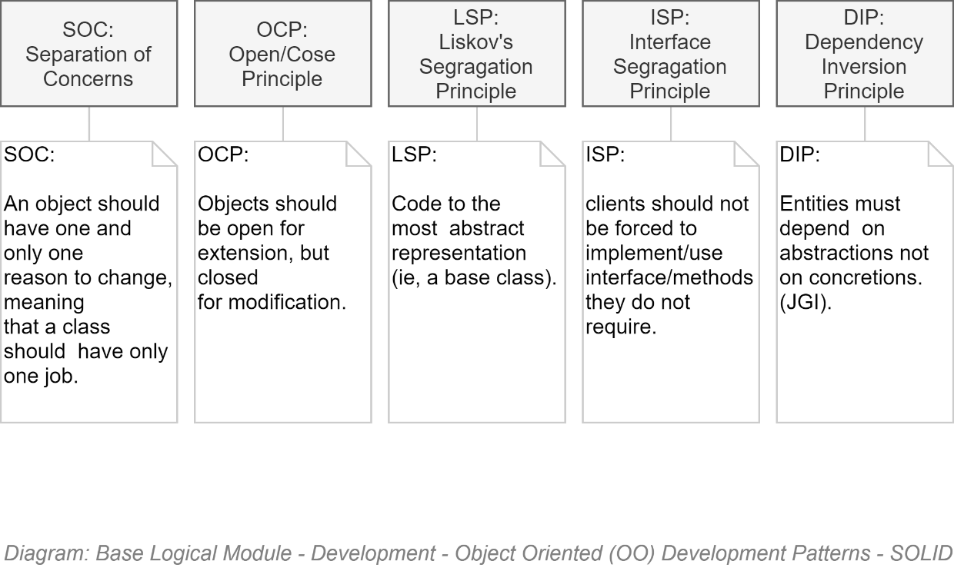

Test-Driven Development
TODO

Technologies
The technologies used depend on the development platform chosen.
The following are those expected if the development platform is .NET Core

.NET Core Based Development
TODO:

Stakeholders

Testers

Components

Packages
Modules are a set of assemblies arranged in the classic DDD formation of the following:
- App.ModuleX.Application
- App. ModuleX.Infrastructure
- App. ModuleX.Shared
- App. ModuleX.Domain

Tip:
The Base Module generally has lots happening in its Infrastructure Module and little in its Domain Assembly – whereas other Modules (Business Modules) have generally little to nothing in their Infrastructure Assembly, and more happening in their Business Domain Assembly.

A solution is composed of a Base Module, on which multiple Business Modules can be developed in parallel:
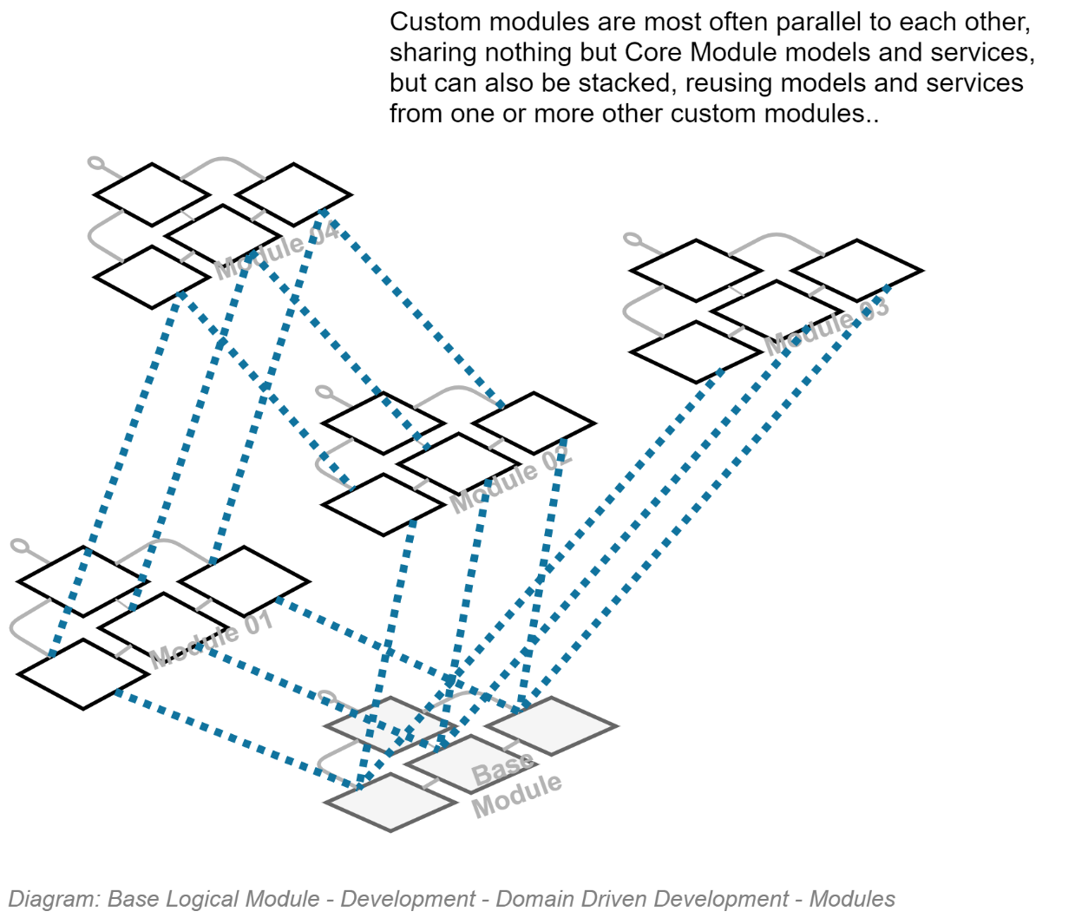

Classes

Security

Configuration Information

Service Integration Credentials & Key Vaults

In Transit
As per the Design Principles and summarised in the Security View, all communication between internal and external devices must be secured by encryption. Therefore, all HTTP based traffic must over HTTPS, maintained by BAU to use the latest version of the TLS standard.

OWASP
The Open Source Foundation for Application Security Project (OWASP) has developed the API Security Top 10. The latest version at this point in time (2020) is the 2019 version, the IDs of the risks being:
- API1:2019 Broken Object Level Authorisation
- API2:2019 Broken User Authentication
- API3:2019 Excessive Data Exposure
- API4:2019 Lack of Resources & Rate Limiting
- API5:2019 Broken Function Level Authorisation
- API6:2019 Mass Assignment
- API7:2019 Security Misconfiguration
- API8:2019 Injection
- API9:2019 Improper Asset Management
- API10:2019 Insufficient Logging & Monitoring

API Development

API Versioning
API Version information is an essential element of a complete URI.
Requests using an URL that does not include an API Version number in the URL must return an error HTTP code.
Note:
The use of a term such as “LATEST” [version] is not an acceptable solution, as client systems will stop working as expected upon breaking changes in APIs.
Requirement:
Older versions of APIs MUST be kept functioning in parallel for a published period (e.g.: 6 months) to allow service clients time to update their code to consume the latest version.

Notification & Redirection

Quality Requirement:
Older versions of APIs must indicate to consuming service clients that they are not consuming the latest version of an API.
The rationale is that although older versions of APIs are to be kept running in parallel for a duration, this state is not permanent.
Use HTTP headers to return:
- A non-200 HTTP response code.
- A single word enumeration value to indicate the state of the API (Draft, Latest, Superseded, Removed, Retired).
- The versioned URL of the latest version of the API (if Superseded).
Note:
As usual when an international standard is not yet available to guide development, avoid re-inventing the wheel, research for the latest best practices, present and obtain approval from the lead architect.

Services

Base Infrastructure Services
The core infrastructure services offered within the Base Module, for use by itself -- and Modules dependent on the Base module -- follow classic DDD recommendations and include (but not limited to):

- ContextService: a service to manage the current operation’s context.
- ImmutableHostSettingsService: a service to manage immutable settings of the host device (wrapping access to web.config).
- DiagnosticsTracingService: a service to trace rolling diagnostic exceptions.
- ExceptionManagementService: a service to manage and record exceptions.
- LocalizedCachingService: a service to cache resources closest to use, in the format closest to use, by the user agent’s culture-region code.
- ObjectMappingService: service to manage the mapping of application entities to versioned DTO objects, and back again.
- ValidationService: a service to manage the object and property validation of objects.
- AuthorisationService: a service to manage access operations by principals.
- BlobStorageService: provides managed control of private and public Blob Storage.
- TenantManagementService: a service to manage Tenants.
- PrincipalManagementService: a service to manage System Principal records.
- PrincipalRoleManagementService: a Setting to manage relationships between System Principals and System Roles.
Important:
May rely on external services (e.g.: EOI, Attributes, Relationships) to provide hints as to how to allocate roles – but role allocation is per system (not monolithic/centrally controlled).
- SessionManagementService: a service to manage one or more current active sessions per Principal.
- SessionOperationService: a service to persist untamperable auditable records of Principal initiated operations within a Session.
- MutableSettingsService: a setting to sync across hosts mutable Settings.
- MediaUploadService: orchestration service to manage the upload of media.
- MediaMalwareVerificationService: validates uploaded media.
- MediaMetadataService: develops a metadata object to describe uploaded media (mimetype, extensions, dates, whether contained malware, whether it was persisted, etc.).
- RepositoryService: provides managed access to relational storage.
- UnitOfWorkService: a service to manage batch persistence across tiers.
- NotificationService: a service to manage notifications to and among system users.
- IUniversalDateTimeService: a service to return UDT datetimes.
- ISMTPService: a service to deliver outward bound email notifications.
- IDbContectPreCommitService: a service to intercept database operations to ensure cleanup and logging is handled centrally.
- IConversionService: a service to convert values from one type to another.
- ITelemetryService: a service to manage the collection and recording of telemetry.

Service Design
This is a living document: as time permits further technical definitions and design of the above services will be included.

Service Façade
The Service Façade exposes the following appropriately queryable ODATA REST Controllers.
The following list of APIs mirrors what is expressed in the Service Interoperability View.

Base Module
- ConfigurationStepRecordController
- DataClassificationController
- ExceptionRecordController
- MediaMetadataController
- NotificationController
- PrincipalController
- RoleController
- SearchController
- SessionController
- SessionOperationController
- SystemDeveloperController
- SystemDocumentationController
- SystemInformationController
- TenantController

Note:
The APIs are appropriately accessible – depending on the controller and data type, information will be made available depending on the Authorisation granted to the current Session’s Principal.

Business Module's Service Facade
The APIs that are exposed via a Business Specific Module Service Façade are addressed in a separate – thin -- SAD deliverable.

Appendices

Section Synopsis

Document

Document Conventions

Document Structure
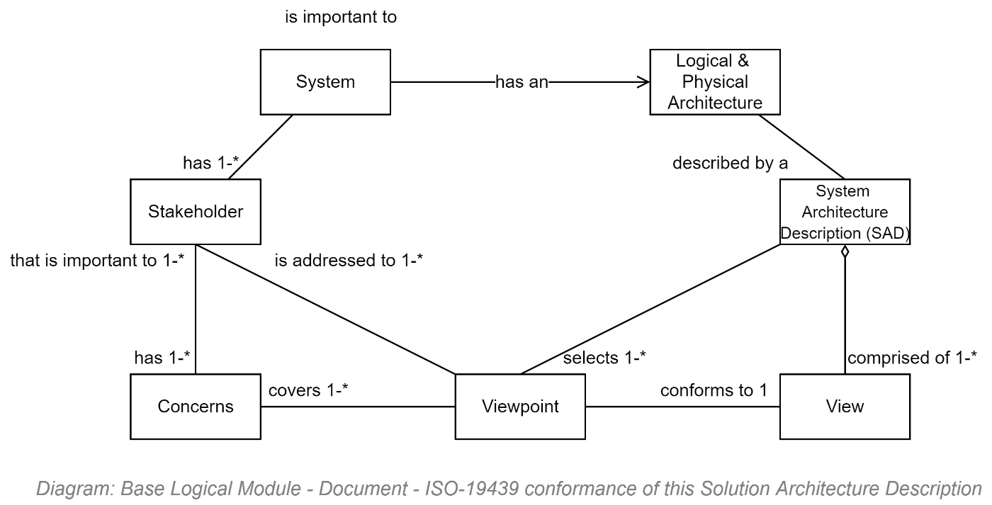

Document Audience
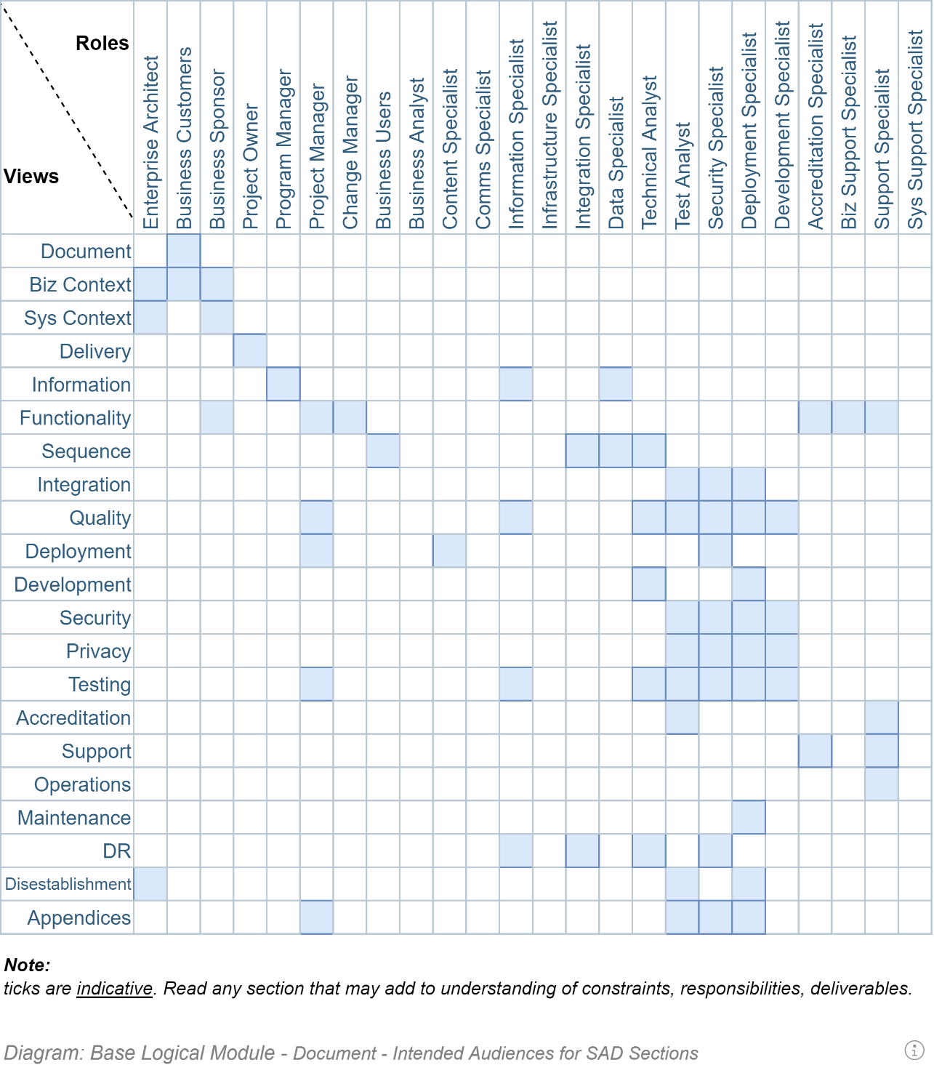

Document Asides
This document is peppered with asides – highlighted boxes of text – that are of one of the following types:
- Information/General Note
-  Tip/Recommendation (SHOULD)
- Warning (SHOULD NOT)
-  Prohibition (MUST NOT)
- Requirement (MUST) (which should be mirrored in the project’s requirement & therefore work items tracking service).

Document Formatting Conventions
The following are examples of formatting used throughout the document.
Note:
They are provided to facilitate if and as required the common task of Format Painting style.
- Text
  - Sub
  - Sub
- Text

https://any.web.link
Image or Table Caption

A | Table | Example
Row  Header | Row using Body Text

Project

Background History (Extended)
TODO: Add any relevant history for context.

Acronyms & Terms

Terms

Business

Business Capability

Business Service

Business Function

Business Process

Business System

Group
A set of Persons who are voluntarily associated in one or more Roles to achieve a purpose.

RASCI
An acronym for Responsible, Accountable, Supporting, Consulted, Informed.
Note:
CRIMEAS is a similar acronym standing for: Consulted, Responsible, Informed, Managing, Everyone else, Accountable, Supporting.

Stakeholder
A Person who is a RASCI member of a purposeful Group.

Strategy
A long term, integrated & unified set of flexibly designed goals and objectives to take advantage of opportunities and mitigate threats to reach an organisation's goals and objectives while consuming the least amount of resources/treasury. See Policy.

Steward
Acting on behalf of an Owner, has the same responsibilities and opportunities as an Owner, bar the Accountability.

Owner
The single Accountable person.
Data Custodian
Manages the availability of the data, ensuring provisioning, backups, servers and network are performing as required. A Data Custodian does decide who has access, nor how it is used.

Policy
An organisation defined framework to act as guidelines and permit rational decision making to adhere to Strategic outcomes. It is helpful in highlighting the rules, value and beliefs of the organisation. Policy is subservient to Strategy. A Strategy is a dynamic plan for action, whereas Policies are stable plans for decision making. A Strategy is to manage the exterior, whereas Policies are for handling the interior.

Data Owner
A data Owner is concerned with the risk and appropriate access to data.

Data Steward
A Steward is interested in the meaning of the data, and the data's correct usage.

Role
A logical assembly of Responsibilities and Permissions, which are conferred on one or more Persons within a purposeful Group of persons.

Technical

Actor

Agile [delivery methodology]
A respected approach to technology delivery at pace by experienced resources working together with minimal planning, oversight & documentation overhead.
The methodology emphasises rapid and iterative delivery of change for user stakeholders to respond as quickly as possible, informing future development direction decisions.
It is a foundational concept of the more mature and complete DevOps and SecOps delivery methodologies.
See MVP.
Warning:
Agile does not mean system development must be begun immediately at the expense of planning in order to get something in front of stakeholders.
The first iterations are used to set up an online project collaboration space, where project documentation -- including this manual -- are available to all stakeholders. This project space is the first service lifetime deliverable.
The next iterations should be a used to develop a bare-bones, “just-enough”, achievable, technical design for review and consensus by appropriate stakeholders before starting. Such a technical design roadmap, although not the final information service itself, is also a deliverable.
The next iteration(s) are used to focus on developing an automated test and delivery pipeline. This too is a deliverable.
Only after the above deliverables are well on their way, start iteratively delivering the next deliverable -- the information service itself.
Finally, when the backend service is starting to expose usable APIs, start developing the final deliverable – the service client user interface.
Important:
Whatever you do, don’t start from the interface (that’s akin to designing a car starting with the panelling, expecting it to be a good source of information on which to design the internal engine).

Business Analysts:
a specialist who developers a complete listing of Stakeholders – and then interviews them for an as complete as possible list of both Functional and Quality requirements. The (combined) System Requirements are the source of the objectives an architect must meet with a system design.

Continuous Delivery:
the automatic building but controlled automated deployment of committed change.
Note:
The difference between a Continuous Delivery Service and a Continuous Deployment Service is that delivery to target environments with a Continuous Delivery Service is a *decision* (by change control, accreditation services, etc.) -- whereas in the second case, every commit to the code base that passes all automated tests is trusted to be deployed to production immediately.
This Project uses a controlled, audited, Continuous Delivery based approach.

DevOps:
a more holistic approach to technology delivery which also addresses ongoing operational needs and the collection of feedback to inform ongoing iterative development and delivery of changes to better meet expectations and changing circumstances.
See SecOps.

Domain: an area of specialised knowledge.
Generally used to keep separate and solve business domain independently from technology domains. All IT systems are the merging of several different domains, including the following common distinct domains: Business, (Business Information and Business Processes), Users & Group management, User Support, Technology Automation & Integration, and Security, Privacy & Accreditation.

Domain Driven Design:
a system design approach to developing systems to equally meet the domain requirements of multiple stakeholder groups. The alternative is addressing one group above others (e.g.: Business, or IT) making it difficult for other stakeholder groups to assist with providing value to users.

Minimum Viable Product (MVP):
Minimal Viable Product. Due to misunderstanding and/or misapplying Agile methodology concepts too often ends up instead becoming an outcome demonstrating “Missing Valuable Planning”.

SecOps:
a delivery methodology: an enhancement of DevOps, emphasising the Security, Privacy and optionally Accreditability of every system delivery.

Stakeholder:
groups of people with a RASCI relationship to a system's commissioning, discovery, design, development, delivery, usage, operations, maintenance, decommissioning.

Stakeholder Analysts:
a more appropriate term for Business Analysts. Business Analysts, hired by project managers embedded in business groups, most often capture only business stakeholder requirements, at the expense of all other stakeholders (Privacy, Security, Support, Operations, Maintenance, Reporting, Data warehouse, etc.)

System Requirements:
the term to describe the combination of the Functional and Quality Requirements. Can be a living document, but preferably it is an online database that all stakeholders can reference online within the project’s ALM space.

Test Driven Development:
an approach to development which emphasises Test Analysts defining automatable test conditions to non-ambiguously, rapidly and repeatedly prove work item objectives are being met.

Mōari Terms
Our nation is multi-cultural welcoming, with 2 official national cultures with 3 official languages. To ensure this system is accessible and understandable in all official languages, ensure the system is designed from the ground up to use Maori terms and viewpoints.
The following are a rudimentary selection of common terms in this country and industry.

Atua
Spirit ancestor, god, demon, supernatural being.

Āko
Learning.
To Teach & to Learn.
See: Tirewa (Framework of learning).
Usage: Kahui āko.

Ākonga
Student.
See Āko ("Learning"), Kaiko ("Teacher"), and Kura ("School").

ā-waha
Oral.
Use: reo-ā-waha: oral language

Āheinga Reo
Language Abilities

Hapu
Common ancestor tribal group.
See whanau ("extended family"), whakapapa ("grounding/lineage").

Harakeke
Flax.
See Rito ("heart shoot of the flax").

Herere / Herenga
Obligation / Constraint.

Iwi
Tribe/Nation.

Ipurangi
Stream / Internet.
Use: Te Kete Ipurangi ("the internet basket").

Kahui
Flocking/Group
See waka ("Container/Canoe/Crew/Flock").
Usage: Kahui Āko.

Kāhui Ako
Community of Learning.
As opposed to Kāhui kura ("group of schools"), which would be a word that does not include early learning, or community.
See: Tira.

Kaitia
Steerer/helmsman.

Kaitiaki
Acting Guardianship.
See Kaitiatanga ("Acting as guardian of nature").

Kaitiakitanga
Guardianship, for the sky, sea, and land.
See Kaitiaki and -tanga

Kaiko
Teacher.
See ākonga ("Student"), Kura ("School"), āko ("Learning").

Kaitaki
Chieftain.

Kanga
Basket.
See Rohe ("Region").
(also, To Swear / To curse).

Kauwhata
To recite oral/spiritual history
Usage: Te Kauwhata Reo system.

Kete
Basket.
See Rohe ("Region").

Kupu
Word / Vocab.

Kura
School.
See Āko ("learning"), Ākura ("Student"), Kaiko ("Teacher"), and Kura ("School").

Mana
Honour/Face.

Manuwhiri
Visitor. Guest.

Marae
Meeting House

Matua
Parent.

Mātai
Field of Study

Noa
Blessing/ Restriction lifting.
See: rahui ("Restriction").

Pae
Measure circumferance/take a reading.
See Pou("Goalpost").
See Rautaki ("Strategy").

Pāngarau
Maths.
See Tuhituhi ("Writing").

Papa
Ground / Earth.
See Whakapapa ("Lineage/Grounding").

Pānui
Read.
See Tuhituhi ("writing"), Pāngarau ("Maths").

Pou
Pillar.
See Whāinga ("Goal").

Puia
Volcano.

Puna
Well. Well up. Center.
Use: Puna Reo: Maori center

Pū
Clump.
Usage Pu harakeke ("clump of flax").

Rāhui
Restriction.
See Noa ("Blessing/Lifting of Restriction").

Rāranga
Weaving.
See harakeke ("Flax").

Rangatira
Hapu Chieftain.

Rautaki
Strategy.
Use: See Rautaki Reo: Maori language strategy.

Reo
Language.
See Te Reo("The language").
Usage Te Reo Māori ("The Māori language").

Rito
harakeke ("Flax") heart shoot.
See Te Rito system.

Rohe
Territory/Domain – can be time zone. Can be a small basket (see Kete).

Ta moko
Facial Tatoo.

Tapu
Sacred

Tākiwa
District

Te
The …

Tikanga [māori]
The correct way.

Tira
Group.
See Kāhui ("Flock").

Tirewa
Framework for reciprocal approach to teaching & learning. See āko("Learning").

Toa
Warrior

Tohunga
Expert in a field

Tumuaki
Crown of the head. Person in charge of an organisation. Principal.

Tūrangawaewae
Standing place – where one has a right to standing, through whakapapa.

Tuhituhi
Write.
See Pāngarau("Maths").

Whaka-
Towards/Directed towards/Make happen.
See: whakapapa ("Grounding/Lineage").

Whakapapa
Lineage/Grounding.
See whaka- ("towards") and papa ("earth/ground").

Waka
Boat, Container, Canoe. Flock.
See kahui ("Group/Flock").

Whānau
Extended Family. See Hapu.

Whāinga
Goal. Destination?
See Pou ("post").

-tanga
Converts a verb into a Noun.
Usage: Kaitiatanga

Acronyms

Business
TODO: Add business specific Acronyms

Technical
The following are a collection of common Acronyms used to refer to technical concepts and components.

AAD: Azure Active Directory

AD: Active Directory

API: Application Programming Interface
API is an acronym for Application Programming Interface. An API is a set of routines, protocols, and tools for building web-enabled and mobile-based applications. The API specifies how you can authenticate (optional), request and receive data from the API server.
When used in the context of web development, an API is typically a defined set of Hypertext Transfer Protocol (HTTP) request messages, along with a definition of the structure of response messages. Web
APIs allow the combination of multiple services into new applications known as mashups.

CSS: Cascading Style Sheets

CURIE
A Compact URI. Learn more at https://en.wikipedia.org/wiki/CURIE

DSaC: Database Schema as Code

DDD: Domain Driven Development
A system design approach to cost-effectively design resilient and fit for purpose systems to meet the domain requirements of multiple stakeholder groups.
Most effectively used in conjunction with SOLID development principles.

HTML: Hyper Text Markup Language

HAL: Hypermedia Application Language
An RFC proposed JSON based expression of HATEOS link information within ReST-ful responses, for Service Clients to dynamically render navigation options.

HATEOS: Hypertext as the Engine of Application State
A constraint of the ReST application architecture that keeps the RESTful style architecture unique from most other network application architectures is the returning of related links in the response Content or Headers.
It allows the service agent client to dynamically present links to appropriate related resources.
Note:
There is no agreed standard for HATEOS – although refer to HAL or RFC 5988 (Web Linking) as potential standards based option.
The term “hypermedia” refers to any content that contains links to other forms of media such as images, movies, and text.

IaC: Infrastructure as Code

IdP: Identity [Token] Provider

JSON: JavaScript Object Notation
JSON is an acronym for JavaScript Object Notation. JSON is a format for structuring data that is sent back and forth via an API. JSON is an alternative to XML. REST APIs more commonly respond with JSON – an open standard format that uses human-readable text to transmit data objects consisting of attribute–value pairs.

MPA: Multi-Page (Server-based) Application

OIDC: Open Identity Connect

OO: Object Oriented

PWA: Progressive Web Application

ReST: Representation State Transfer
See HATEOS.

UI: User Interface

UX: User eXperience

SAML: Secure Application Markup Language

SDK: Software Development Kit
When APIs are published, it’s typical to accompany the APIs with documentation that shows how the API authenticates, how it can be queried, and what the appropriate responses are.
To help developers get a head start, companies often also publish a Software Developer Kit to actively demonstrate the use of the API, for investigation by developers.

SOAP: Simple Object Access Protocol

SPA: Single Page Application

WAN: Wide Area Network
A multi-port, multi-protocol network used to connect multiple LANs.

WSDL: Web Service Definition Language

WWW: World Wide Web
The HTTP/S over port 80/443 subset of the world-wide WAN.

XML: eXtensible Markup Language
XML is an acronym for eXtensible Markup Language. XML is a markup language used to encode data in a format that is both human-readable and machine-readable.
Largely replaced by the lighter weight and simpler JSON.

Risks

Direction
Lack of value focused Objectives:
the technical system is not the objective. The service to end users is the primary objective. The functionality to stakeholders equitably distributed amongst stakeholders is the second objective.
Lack of Guiding Principles:
unprincipled delivery encourages stakeholders to compete for resources rather than collaborate.
The principles must include principles to cover the following concepts:
Team: e.g.: Automation before manual activities
Delivery: e.g.: automated delivery pipeline before delivered system.
Device: e.g.: Small mobile screens before static desktop screens
Channel: e.g.: voice before web before print
Deployment: e.g.: separate Service/Service Façade/Client tiers

Delivery
ISO-25022/12/10 are focused on Service qualities.
And Roles and Personas are focused on Service Functionality.
But there are no Project Delivery Qualities to guide Delivery.
Decrease Risk by working from the bottom up (clunky concrete foundations that nobody ever sees, needed to be done down in the mud, before flashy screens – rather than the other way around).
Decrease Risk by focusing on providing autonomy to work to prepared, common plans and agreed schedule – rather than focusing on controlling resources to work to plans to be developed in groups.
Decrease Risk by ensuring signed T&Cs by stakeholders (ensuring PMs, Devs & Testers have read the documents and agree to working to them, before they are accepted into the delivery team).
Decrease Risk by avoiding designing interfaces before designing services and flow between them.
The only tool PMs have at their disposal is to "descope" & "manage expectations"
And use it too early. Projects should be allowed to fail a bit before work is necessarily descoped.

Discovery
Business User stakeholder focused.
A by-product of analysts being referred to Business Analysts (as opposed to Stakeholder Analysts) – and having the most contact with business users compared to other stakeholder groups (e.g.: Service Consumers, Business Partners, Risk Specialists, Security Specialists, Support Specialists, Operations Specialists, Maintenance Specialists), Discovery produces lopsided User Stories.
Often, their only representation is via the project’s Architect – and even so, only in the form of Quality Requirements. This means they end up not being well represented in terms of their required Functionality.

Definition
TODO

Design
System Designers may try to design a WAN based service, thinking to emulate LAN concepts.
The service is not designed to API-First principles, exposing all operations by appropriately authorised APIs.

Development
Business Owner are often biased to prioritise work items that are presentable to business stakeholders, relative to work items for other stakeholder groups.
Developers are not trained to reject working on Work Items whose User Stories and Tasks have not been reviewed and completed with Test Definitions by Test Analysts.
Developers are not trained to develop features and user stories in a separate code repository branch, which would better allow the build pipeline to abort attempts to merge non-quality assured code into the main production branch.
Developers are not trained to develop securely.

Quality Assurance
A risk is that Quality Assurance is done by Testers, as opposed to being done by Test Analysts. Testers test the software manually according to scripts. Test Analysts analyse a Stakeholder Analyst developed User Story & Tasks and complete it with Test Definitions.
The Developers develop the Test Definitions into Test Scripts to be run by the Delivery Pipeline. Test Analysts never repeat tests manually – they only do exploratory testing on the system.

Deployment
The delivery pipeline only focuses on compiling code, leaving the building of environments, and running tests to manual processes.
The build pipeline does not run automated tests.
The build pipeline does not protect the merging of non-quality assured branches into the production branch.

Support
Support Specialists are not provided a means to onboard/offboard users.

Operations
The system is deployed without a DR process.
The system DR’s data backup & recovery functionality is continually tested (by restoring backups to a reporting database).

Maintenance
The services’ architecture is not developed according to Domain Driven Design (DDD) principles.
The code is not developed according to SOLID OO principles.

Decommissioning
The system is designed without a means to export key information in a machine-readable -- industry standard, if available -- format.

Principles

Summary of Principles Applicable to NZ National Services
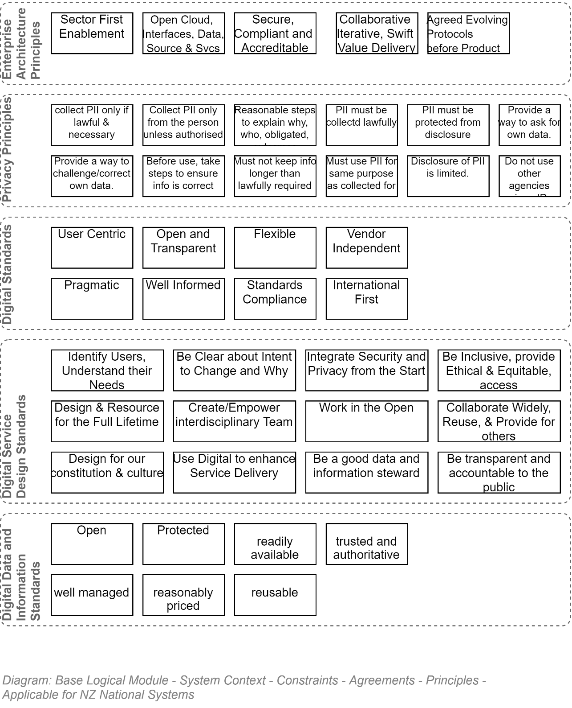

NZ Privacy Principles
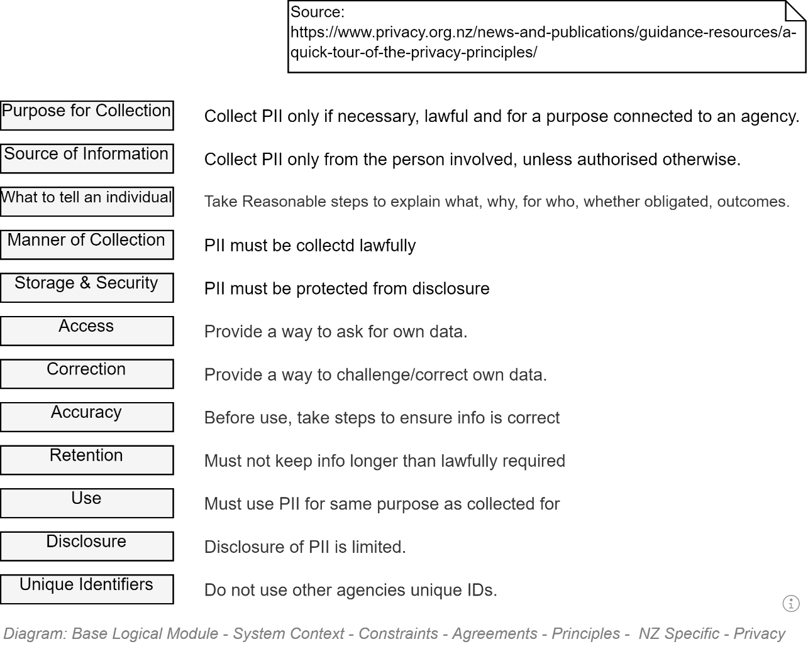

NZ Specific - Digital Standards Principles
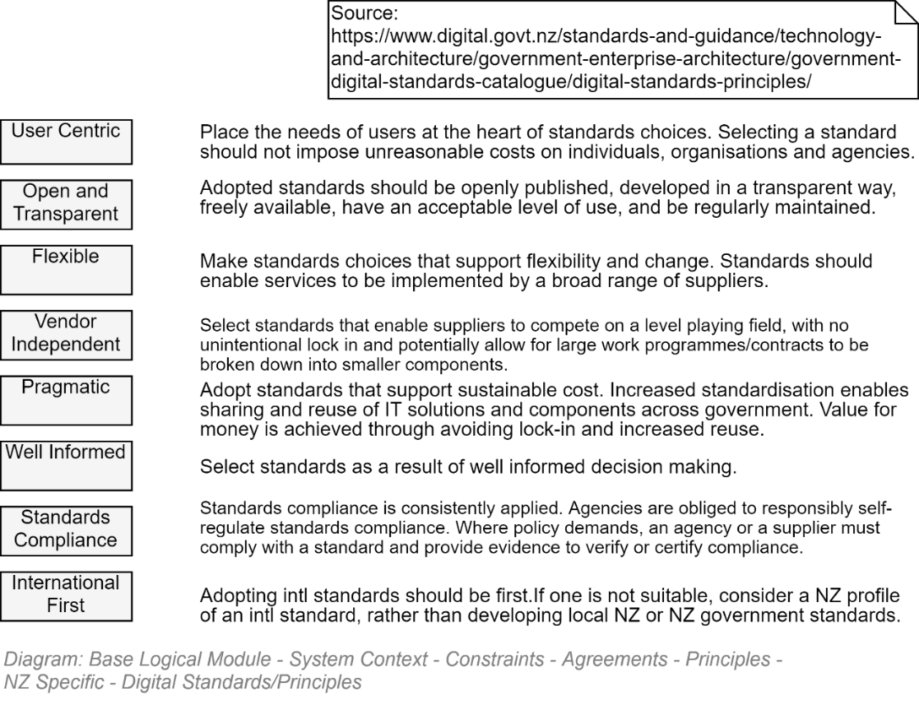

NZ National Service Specific – Digital Service Design Standards Principles
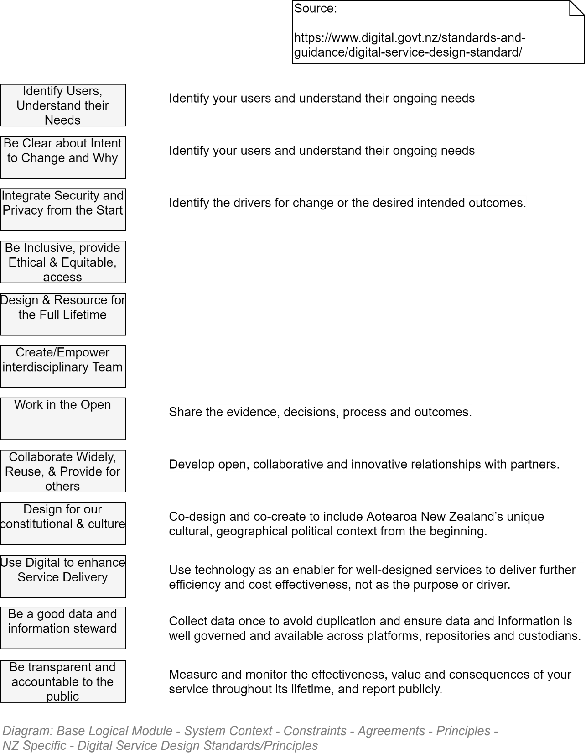

NZ National Service Specific – Data and Information Management Principles
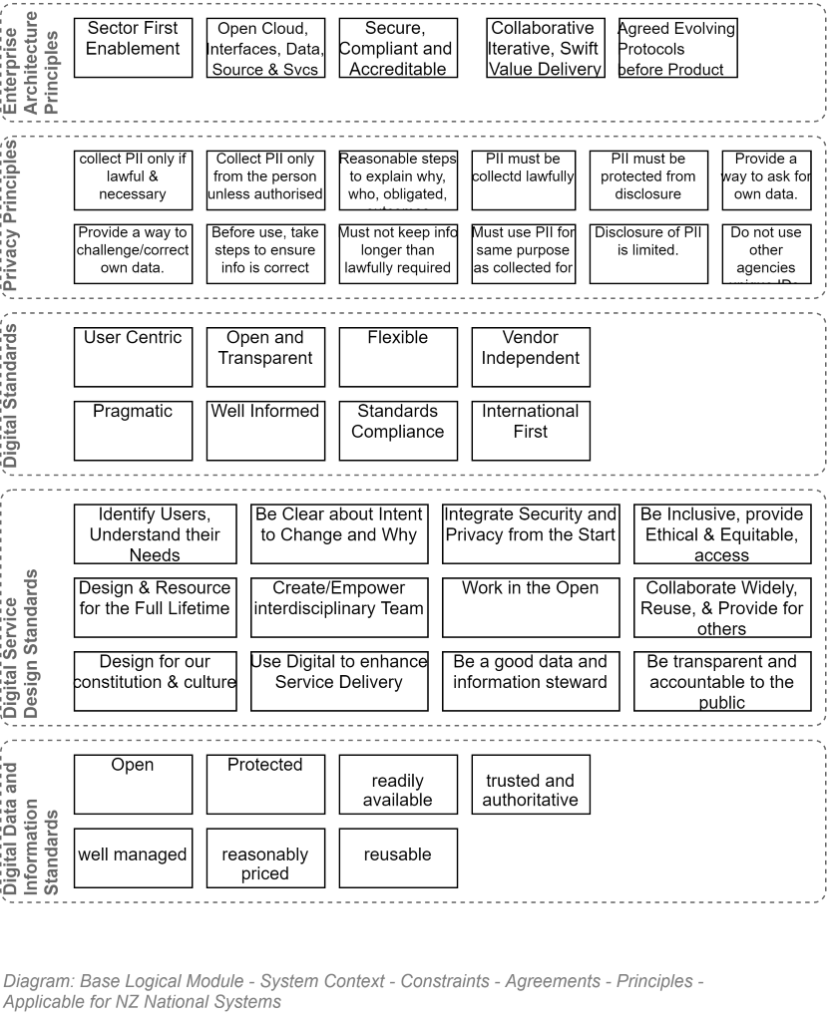

NZ MOE Enterprise Design Principles
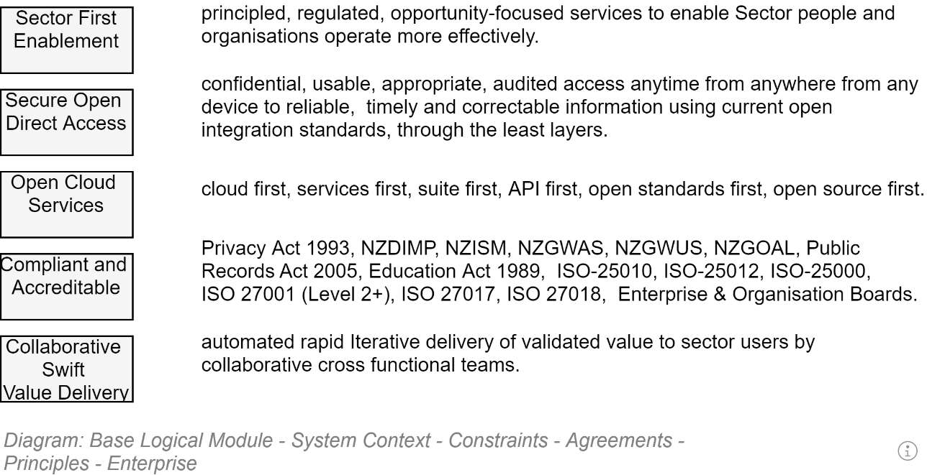

Universal Design Principles
The basic principles of Universal Design developed under Ron Mace in 1997 are listed below:
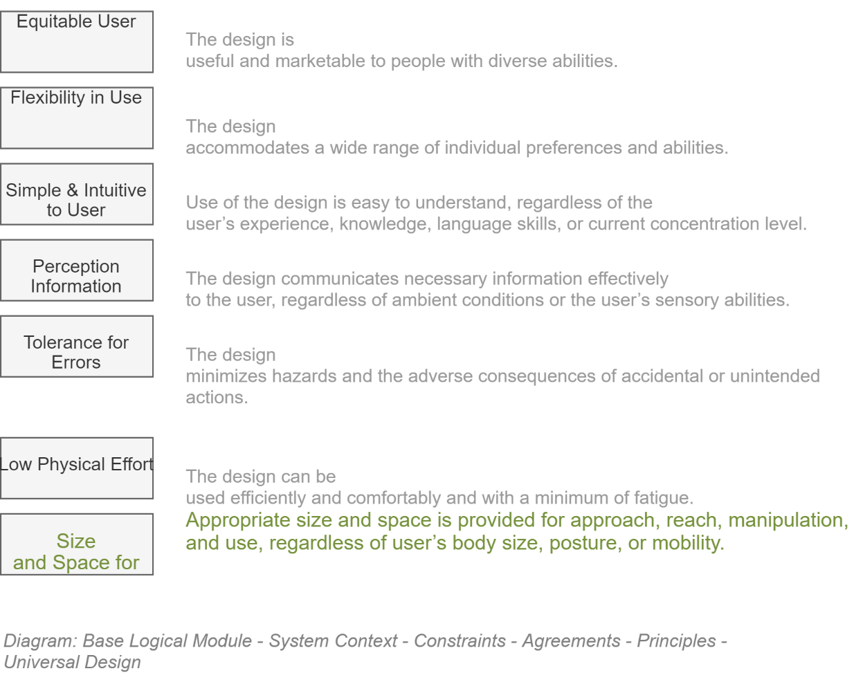

Equitable Use
The design is useful and marketable to people with diverse abilities.
- It provides the same means of use for all users: identical whenever possible; equivalent when not
- It avoids segregating or stigmatizing any users.
- Provisions for privacy, security, and safety are equally available to all users.
- The design is appealing to all users.

Flexibility in Use
The design accommodates a wide range of individual preferences and abilities.
- It provides choice in methods of use.
- It accommodates right or left-handed access and use.
- It facilitates the user’s accuracy and precision.
- It provides adaptability to the user’s pace.

Simple and Intuitive Use
Use of the design is easy to understand, regardless of the user’s experience, knowledge, language skills, or current concentration level.
- It eliminates unnecessary complexity.
- It is consistent with user expectations and intuition.
- It accommodates a wide range of literacy and language skills.
- It arranges information consistent with its importance.
- It provides effective prompting and feedback during and after task completion.

Perceptible Information
The design communicates necessary information effectively to the user, regardless of ambient conditions or the user’s sensory abilities.
- It uses different modes (pictorial, verbal, tactile) for redundant presentation of essential information.
- It provides adequate contrast between essential information and its surroundings.
- It maximizes “legibility” of essential information.
- It differentiates elements in ways that can be described (i.e., make it easy to give instructions or directions).
- It provides compatibility with a variety of techniques or devices used by people with sensory limitations.

Tolerance for Error
The design minimizes hazards and the adverse consequences of accidental or unintended actions.
- It arranges elements to minimize hazards and errors: most used elements, most accessible; hazardous elements eliminated, isolated, or shielded.
- It provides warnings of hazards and errors.
- It provides fail safe features (i.e., an undo operation being the best option).
- It discourages unconscious action in tasks that require vigilance (i.e. modal validation beforehand being second best).

Low Physical Effort
The design can be used efficiently and comfortably and with a minimum of fatigue.
- It allows user to maintain a neutral body position
- It uses reasonable operating forces.
- It minimizes repetitive actions (e.g.: the least number of clicks to get anywhere).
- It minimizes sustained physical effort.

Size and Space for Approach and Use
Appropriate size and space is provided for approach, reach, manipulation, and use, regardless of user’s body size, posture, or mobility.
- It provides a clear line of sight to important elements for any seated or standing user.
- It makes reaching to all components comfortable for any seated or standing user.
- It accommodates variations in hand and grip size.
- It provides adequate space for the use of assistive devices or personal assistance.

Organisation Principles
The following are principles specific to this organisation.

Enterprise Principles
Maximize Benefit to the organisation [EAP1]

Statement | Information management decisions are made to provide maximum benefit to the enterprise (education inc) as a whole.
Rationale | This principle embodies "service above self". Maximise benefits to the education system (e.g. alignment to the Education System Digital Strategy).  Decisions made from an enterprise-wide perspective have greater long-term value than decisions made from any particular organizational perspective.  Maximum return on investment requires information management decisions to adhere to enterprise-wide drivers and priorities.  No minority group will detract from the benefit of the whole. However, this principle will not preclude any minority group from getting its job done.
Implications | - Achieving maximum enterprise-wide benefit will require changes in the way we plan and manage information. Technology alone will not bring about this change.  - Some organizations may have to concede their own preferences for the greater benefit of the entire enterprise.  - Application development priorities must be established by the entire enterprise for the entire enterprise.  - Applications components should be shared across organizational boundaries.  - Information management initiatives should be conducted in accordance with the enterprise plan. Individual organizations should pursue information management initiatives which conform to the blueprints and priorities established by the enterprise. We will change the plan as we need to.  - As needs arise, priorities must be adjusted. A forum with comprehensive enterprise representation should make these decisions.
Single Source of Truth [EAP2]

Statement | Single Source Of Truth (SSOT) refers to the practice of structuring information models and associated schema such that every data element is maintained and updated in only one place.
Rationale | - When any data element is updated this update is propagated to the enterprise  - Data is consistent (i.e. there is no risk accessing outdated data)
Implications | Theoretically any possible linkages to this data element (possibly in other areas of the relational schema or even in distant federated databases) are by reference only. However this is rarely possible (COTS systems, performance across boundaries, aggregated functions). In addition storing data by reference either tightly couples systems together or introduces latency at a record level which is not desirable. So generally the implementation of SSOT is via a service bus that publishes data to various other consumers of this data.
Consolidate Similar Functions [EAP3]

Statement | Where multiple business functions exist that are the same or very similar consolidate them together.
Rationale | - Align IT with business function (SOA Principle)  - Reduce duplication of both function and data  - Reduce costs through clearer consolidated business functions (otherwise integration can be overly complex, and adds significant costs).  - “Just because we "can" integrate independent systems, doesn’t mean that it should be first choice for developing business solutions. Integration adds overhead and additional layers of complexity that should only be done when necessary. The first choice, whenever feasible, should be to consolidate disparate systems that perform similar functions into a single system." [From TOGAF]
Implications | - Agencies are required to architect their solutions with a holistic view across the whole enterprise (i.e. education), in order to see opportunities to simplify our integration needs.  - Analysis of ‘similar’ functions needs to be made in order to determine feasibility of consolidation.  - For some scenarios, integration is the only option, as system consolidation may not be cost-effective and rationalisation of the business requirements may not prove viable. The Master data management strategy is dependent on integration.
Name | Reusable Shared Services [EAP4]
Statement | Education agencies will only achieve reuse between services if delivery teams adhere to accepted shared messaging standards and support a sector-wide data model.
Rationale | The adoption of a service-oriented architecture supports the business goal of providing rapidity and agility in the delivery of integrated solutions. This goal is achieved through the development of loosely coupled interoperable services that promote re-use across the enterprise
Implications | The preferred approach to integration is to develop loosely coupled web services that adhere to the principles of integration.

IT Architecture principles
- The IT Architecture principles are:

Name | Business Driven [AP1]
Statement | Investments in information systems should be traceable to an identified business need.
Rationale | Business needs drive the IT Architecture.
Implications | - Solution investments need to be linked to the business investment process.  - Changes in business needs may result in new information system requirements.  Data should not be captured unless it aligns to current or future business objectives or strategy. A business rationale is required for determining the data we expend resources on.
Name | Maximize Education Sector Benefit [AP2]
Statement | Maximise efficiency and minimise TCO across the sector.
Rationale | Maximise benefits to the education system (e.g. alignment to the Education System Digital Strategy).  The Ministry has an obligation to government to make best use of the funds provided to it. This includes ensuring that we don't duplicate work done elsewhere in the sector and that we ensure that all we do is done with the sector in mind.
Implications | - The ministry must cooperate with the sector to ensure that sector funds are spent effectively.  - Where technology is used to maximise education sector benefit, approved technologies will be adopted as a priority (e.g. mainstream technology - see AP3 - and enterprise licensed)
Name | Mainstream Technology [AP3]
Statement | Production IT systems must use industry-proven, mainstream technologies except in those areas where advanced higher risk solutions provide a substantial benefit.
Rationale | The ministry does not want to be on the leading edge for its core service systems. By not being so risk will be minimised.
Implications | Only products with a substantial experienced user base will normally be considered by the Ministry.
Name | Interoperability [AP4]
Statement | Software and hardware should conform to defined standards that promote interoperability for data, applications and technology.
Rationale | - To ensure consistency, thus improving the ability to manage systems.  - Simplification of information technology toolset.  - To protect existing IT investment, maximising ROI and reducing costs.
Implications | - Interoperability standards and industry standards will be followed unless there is a compelling business reason to implement a non-standard solution (also see AP5)  - A process for setting standards, reviewing and revising them periodically, and granting exceptions must be established.  - The existing IT platforms must be identified and documented.
Name | Open Based Standards [AP5]
Statement | Industry standards selected within the Enterprise Architecture will be followed unless there is a compelling business reason to implement a non-standard solution.
Rationale | - The promotion, utilisation and adherence to industry, government and standards supported by multiple vendors will avoid vendor and platform lock-in.  - Facilitate interoperability both internally and externally.  - Facilitate componentisation (flexibility and speed to market).
Implications | - Interoperability standards and industry standards will be followed unless there is a compelling business reason to implement a non-standard solution (also see AP5)  - A process for setting standards, reviewing and revising them periodically, and granting exceptions must be established.  - The existing IT platforms must be identified and documented.
Name | Scalability [AP6]
Statement | The underlying technology infrastructure and applications must be scalable in size, capacity and functionality to meet foreseeable changing business and technical requirements.
Rationale | Growth capability should be a driver for all aspects of the system architecture
Implications | Component based selection approach will enable the architecture to grow with the business supporting configurable, scalable and adaptable components that can respond to the business requirements.
Name | Reliability [AP7]
Statement | All systems, subsystems and components must be designed with the inclusion of reliability and maintainability as an integral part.
Rationale | Learners, providers and staff depend on the availability of Ministry of Education services. They must be reliable in-order-for the Ministry to meet its obligations to these stakeholders.
Implications | Reliability must be designed in from the beginning.
Name | Data is managed as a shared Asset [AP8]
Statement | Data should be captured with all identified users in mind so that it can be shared amongst them rather than each of them capturing their own data.
Rationale | Timely access to accurate data is essential to improving the quality and efficiency of decision making. It is less costly to maintain timely accurate data in a single application and share it, than it is to maintain duplicative data in multiple applications.
Implications | - To enable data sharing we must develop and abide by a common set of policies, procedures and standards, governing data management and access for both the short and long term.  - We will also need to develop standard data models, data elements, and other metadata that defines this shared environment and develop a repository system for storing this meta data to make it accessible.  - Additional time and investment in initial application design and delivery of more generic solutions.
Name | Shared Services [AP9]
Statement | Data should be captured with all identified users in mind so that it can be shared amongst them rather than each of them capturing their own data.
Rationale | Timely access to accurate data is essential to improving the quality and efficiency of decision making. It is less costly to maintain timely accurate data in a single application and share it, than it is to maintain duplicative data in multiple applications.
Implications | - To enable data sharing we must develop and abide by a common set of policies, procedures and standards, governing data management and access for both the short and long term.  - We will also need to develop standard data models, data elements, and other metadata that defines this shared environment and develop a repository system for storing this meta data to make it accessible.  - Additional time and investment in initial application design and delivery of more generic solutions.
Name | Data is a Valuable Asset [AP10]
Statement | IT systems should be developed in a manner commensurate with the value of the data they manage.
Rationale | Ministry resources can be optimised by applying them to the most valuable data.
Implications | - The value of the data to the organisation needs top be understood.  - The Ministry value chain will define the value of the data that supports it.  - Management need to perceive data as an asset so that they apply resources accordingly.
Name | Cloud First [AP11]
Statement | IT systems should be developed in a manner to align with NZ Government “cloud first” policy [CAB Min (12) 19/8A], while balancing the need to meet agency business requirements and manage risk appropriately.
Rationale | Alignment to core NZ Government IT policy to maximise benefits realisation of cloud adoption (e.g. flexible computing resource, BCP agility, reduced operational overhead, work from anywhere, increased accessibility, common security controls, accelerated industry competition)
Implications | - Clear articulation of an acceptable risk profile of consuming applicable cloud services needs to be understood in the context of the intended use of the cloud platform  - Requires agreement in the enterprise of the term cloud and applicable utilisation models [e.g. see NIST definition https://www.nist.gov/news-events/news/2011/10/final-version-nist-cloud-computing-definition-published]  - Compliance with relevant GCIO cloud framework activities  - Funding model challenges (CAPEX vs OPEX)
Name | Test Architecture Leading to Increased Automation [AP12]
Statement | IT systems should be developed in a manner that considers relevant test architecture to quickly demonstrate successful delivery of quality to stakeholders with increasing use of automation.
Rationale | Support common testing architecture approaches leading to accelerated solution build/testing cycles and the ability to more readily adopt automation; leading to advantages including but not limited to:  - Increased throughput or productivity  - Improved quality or increased predictability of quality  - Improved robustness (consistency), of processes or product  - Increased consistency of output  - Reduced direct human labour costs and expenses
Implications | - Test practice principles to support increased utilisation of automation  - Test artefact templates to support increased utilisation of automation (e.g. common test strategy, sufficient details within test specifications to support automation scripts)  - Adoption of automation tools (approved by relevant parties within MoE)  - Consideration for SDLC/PMO methodology changes to streamline adoption and longer-term use of automation  - Standardised format and presentation of automation based summary test results to business and technical stakeholders
Name | Support Agile Development as Applicable [AP13]
Statement | Projects adopting an Agile methodology must support mandatory (traditional) project and solution delivery controls as required by Ministry governance.
Rationale | - To ensure relevant governance controls within the Ministry continue to function to a required level  - Support/underpin the scope of the project to run within an Agile methodology
Implications | - Granularity of a collection of consecutive user stories (an epic) is clearly understood to support overarching artefacts at the governance level (e.g. high level architecture and design)  - Additional governance gates to approve lower level details as discovered and articulated from within the epic (e.g. low level architecture and design)  - Governance acceptance that the level of detail within a traditional Solutions Architecture Document will be split into two deliverables:  - High level overarching architecture and design (before the start of an epic build phase)  - Lower level architecture and design (during/before the end of an epic build phase)  - Rapid escalation support by Ministry governance when an Agile project requires quick decisions (e.g. update required to the original high level architecture and design to allow the project to continue)  - Clear articulation and visibility of process and RASCI to enable governance  - Creation of necessary templates to support common tasks within the process to enable governance
Name | YAGNI: You Ain’t Going to Need It [AP14]
Statement | Think twice before architecting for solution dynamics which are not yet required.
Rationale | Supporting additional complexity in a solution which is not yet required by appropriate stakeholders comes at a high price and may never be utilised. For example, over architecting for future/unknown resiliency and availability.
Implications | - Clear articulation of requirements (functional and non-functional) for current and anticipated future needs  - Clear sign off and endorsement of requirements by appropriate stakeholders  - Traceability to support governance of proposed architecture back to signed off requirements  - A process to support future uplift of architecture dynamics as requirements evolve
Name | Minimise Complexity [AP15]
Statement | Actively seek to minimise complexity in solutions whilst delivering on current and future benefit requirements.
Rationale | Design solutions that optimise supportability and enterprise adoption during project and operational phases by reducing complexity where possible.
Implications | - Utilise industry standard solution design patterns  - Utilise industry standard operational support models/procedures  - Avoid complex and excessive automation (whilst still delivering on an agreed continuous assurance capability)  - Clear sign off and endorsement of requirements by appropriate stakeholders

Integration Principles

Name | Data Timeliness [IP1]
Statement | Integration should minimise the length of time between when one application decides to share some data and other applications have that data.
Rationale | The longer sharing can take, the more opportunity for shared data to become stale, and the more complex integration becomes.  User expectation – The expectation from modern computer systems is that data will become available almost immediately after input.
Implications | Data should be exchanged frequently in small chunks, rather than waiting to exchange a large set of unrelated items.  Latency in data sharing has to be factored into the integration design
Name | Use Open Standards [IP2]
Statement | Integration services should be built on open standards that promote interoperability, security, and reliability. For example WS*, HTTP, Rest, etc..
Rationale | - There is less chance of being locked in by a specific technology and/or vendor.  - It will be easier for systems from different parties or using different technologies to interoperate and communicate with one another  - Compliance with e-government
Implications | - Strong culture of up to date standards knowledge  - Governance integrated to wider Ministry and AoG  - Roadmap of standards supported (e.g. plan end of life of one standard)
Name | Transport Ignorant of Payload [IP3]
Statement | Integration services may respond specifically to the address or envelope of a message, but where possible, integration services should be ignorant of the content of the message. Business rules relevant to the content will be implemented by either the receiving or sending service.
Rationale | This will reduce cost and complexity for the implementation of integration services and increase flexibility. Operational support and risk is reduced since the only skills/ knowledge sets required pertain to the platform, not the business process. This reduces the number of impacted platforms on which to implement business change which reduces the time to market for all change.
Implications | Avoids poor message design requiring intermediary services to have understanding of message content to be able to handle it intelligently (e.g. when sequence is important).
Name | Business Logic Resides in Core Systems [IP4]
Statement | Co-locate service business logic with the system responsible for supporting the service.
Rationale | Splitting the business logic across platforms adds complexity and cost due to fragmented processes, rules, and logic.
Implications | There may be technology & governance constraints in the core system.
Name | Develop a Common Representation of Data and Process [IP5]
Statement | Define an enterprise domain model in canonical form for describing all web services.
Rationale | Process-driven development of end-to-end solutions.  "The goal of this principle is to create an interchange language that is common to all applications within the enterprise, generic enough to be decoupled from any given application and robust enough to be able to represent the necessary data and process information for any given application. This representation would facilitate communication among the various applications because they would all ’speak the same language’."
Implications | Gaining acceptance of the enterprise-wide model will require a consensus from diverse parts of the business and effective governance.  Can easily get to abstract, and over engineered, need to keep the process simple.  - Master data owners should ultimately be responsible for each subject area.  - We should only be concerned with shared entities and attributes  - Develop incrementally as required and store as a library of definitions

Delivery Methodologies

Comparison of Methodologies
The following is an opinionated table of comparison between different delivery methodologies:
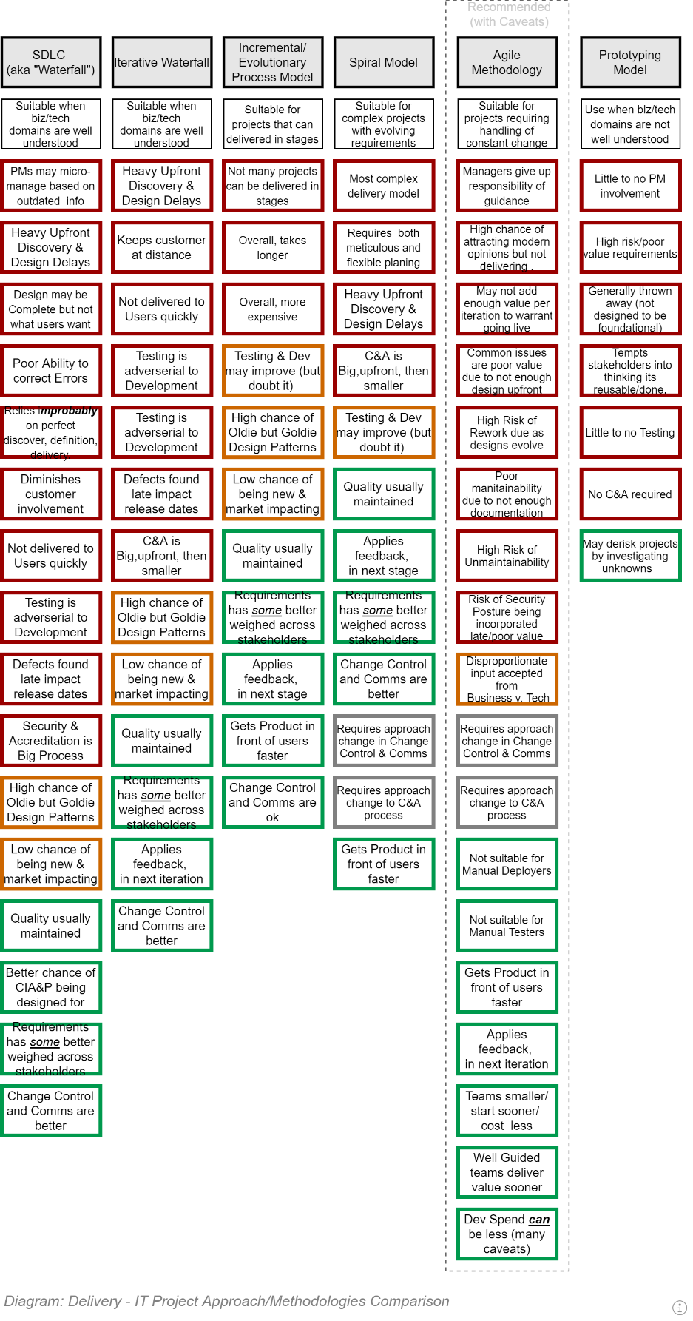

Agile

Agile Epics, Features, User Stories, Tasks
Agile practices refer to Work Items by different names to indicate the scale of the effort.

EPICs
Epics, as the name suggests, are large conceptual divisions of the service that is to be delivered.
Warning:
It’s a common error for developers to think of Epics as very large sets of User Stories/Tasks. Whereas they’re more of a workstream classification – specifying ongoing key concepts needed to be worked on over many releases, often across multiple features.
Epics can be nested.

Features
Whereas Epics are workstreams, Feature [Sets] are large but finite clumps of User Stories, focused on specific functionality.
Features can be nested.

User Stories
User Stories are 3-4 part expressions (Role, functionality, Purpose, Value) of purposeful functionality desired by a User role. They're scoped to be completable within an iteration, preferably within a day's work.
User stories are generally part of a larger Feature.

Tasks
User Stories are composed of:
a) an optional small set of child Tasks
b) each task associated to a set of one or more User Acceptance Tests defined using Gherkin syntax.
Note:
It is a workflow error that increases the risk of projects failing for developers to begin work on User Stories that are
a) not completed with Acceptance Tests
b) completed with an estimated as to its dependencies and effort required (refer to "Agile Poker").

Requirements
Although Epics/Features/UserStories are the most well known work item elements in Agile, Requirements are also used in Agile environments.
For traceability reasons – as well as ensuring that Qualities are addressed by the Acceptance Tests -- User Stories and child Tasks must link to applicable source Functional and Quality Requirements.

Requirements
The following are a list of Requirements recorded as being required by the previously described solution.
Use the list to verify that the Solution's Functional Requirements and Quality Requirements include them.

Functional Requirements
- The service MUST expose all Operations appropriately via Service Façade APIs publicly accessible via the web.
- The service MUST expose APIs to manage rolling immutable Diagnostics Trace Messages.
- The service MUST expose APIs to manage permanent immutable Error Reports.
- The Service MUST expose APIs to manage immutable System Configuration.
- The Service MUST expose APIs to manage mutable Service Settings.
- The services MUST expose APIs to manage permanent immutable Session records.
- The service MUST expose APIs to manage permanent immutable Session Operations audit records.
- The Service MUST expose APIs to manage deployable Modules of logic.
- The Service MUST expose APIs to manage Search functionality that is intuitive, forgiving and culturally capable.
- The Service MUST expose APIs to manage the Permissions developed in each loaded Module.
- The Service MUST expose APIs to manage System Roles developed from adding & excluding Permissions.
- The Service MUST expose APIs to manage the connection to external Identity Services.
- The Service MUST expose APIs to manage nestable Groups.
- The Service MUST expose APIs to manage Group Roles developed from adding & excluding Permissions.
- The Service MUST expose APIs to manage Users.
- The Service MUST expose APIs to manage Users Profile/Preferences.
- The Service MUST expose APIs to manage the Logins of Users in one or more external IdPs.
- The Service MUST expose APIs to manage the allocation of Users to Service Roles.
- The Service MUST expose APIs to manage the allocation of Users to zero or more Groups according to Group Roles.
- The Service MUST expose APIs to manage the creation, sending, delivery of internal and external Notifications.
- The Service MUST expose APIs to manage Collections of Resources.
- The Service MUST expose APIs to manage the uploading of Resources.
- The Service MUST expose APIs to manage the association of Resources to Resource Collections.
- The Service MUST expose APIs to associate Users to Resources in one of a set of Resource Roles.
- The Service MUST expose APIs to manage Resource Workflows.

Quality Requirements
- A Service Client MUST be developed on a different Tier than the Service.
- The Service Client MUST be developed as a PWA SPA.
- The Service Client MUST make available to all users on all their devices, all the Service's API exposed Operations.

Legal
- The Service Client MUST be developed to meet all the organisation's legal constraints, including NZ Government Service obligations towards Security, Privacy, Accessibility, Localisation, Usability, Archiving, EOI, Records, Digital Services and Education.

Security
- The solution's Client interface tier MUST be separate from the solutions server tier and communicate over HTTPS.
- Session ID cookies will be marked with the secure flag to ensure they are not transmitted in the open over port 80.
- The cost of public Certificates MUST be free.
- Certificates MUST have an expiration of less than 90 days.
- The Deployment Agent's Service Account MUST be provided access to a secure Key Vault, to retrieve 3rd Party Service Credentials.
- If Service Accounts developed during deployment come with a Password requiring persisting, it MUST be persisted in a secure storage service (e.g.: KeyVault).
- All communication between system components MUST be encrypted where feasible.
HTTPS must be used for HTTP. Encryption must be specified for TCP (e.g.: databases and caching services) based communication where feasible.
- Authentication MUST be via accredited 3rd party Identity [Token] Provider Services (IdP) specially hardened to protect user credentials and sensitive information.
- External services – including Identity Providers – MUST NOT be used for Authorisation purposes.
- Permission and Role Management and enforcement MUST be a function of the service. The service's logic can consider external information (e.g.: claims on Identity Tokens) when determining how to provision users.
- The service MUST encrypt all databases, using a key persisted in a secure key vault.
- The service MUST encrypt columns containing PII information.
- The service MUST encrypt all database backups.

Usability
- All HTTP servers MUST be accessible via the WWW WAN. Deploying "Internal only" web servers is not acceptable.
- The service MUST develop a copy of the database for eventually right reporting requirements, while disclosing sensitive information by not decrypting database columns containing PII information.
- The service MUST provide externally and appropriately access to secure REST-ful APIs for all service Operations.

Maintainability
- Certificates MUST be developed using automation in the deployment pipeline.
- Certificates MUST deployed using automation in the deployment pipeline.
- The Service Account for web servers MUST be developed using automation in the deployment pipeline.
- Infrastructure MUST be developed by automation in the deployment pipeline, using an Infrastructure as Code (IaC) approach, executed by the continuous delivery pipeline.
- The service MUST provide a standards-based API to provision Users and Groups.
- All Testing -- bar exploratory testing -- MUST be automated and run via a Continuous Delivery Pipeline.

Operability
- The service MUST provide the functionality required of Operations Specialists to not require them accessing the service databases directly.

Resilience
- The service MUST backup the Production data in full once a day, and incrementally every 1-15b minutes.
- The service MUST keep the database's Write Ahead Log (WAL) that was developed between the last incremental backup and the present.

Diagnostics
- The service MUST roll over the operation diagnostic logs every 31 days.
- The Service MUST keep permanent records of Exceptions raised.
Unsorted
- Requests to the service over port 80 will be redirected to port 443.
- Requests over port 80 that include a cookie containing Session ID will raise an Exception.

Required Effort expressed as Work Items
The following is a list of tasks to ensure are added as WorkItems within the ALM’s Work Item Management Service, to be later prioritised as to which work item the group is to work on next.

Delivery Service

Information Service

Service Client
- User Views:
  - Shell Container View:
    - Full Screen:
      - Splash Output View
      - App Information Output View
      - Confirmation:

      - Selectors:
        - Single from List Input View
        - Multiple from List Input View
        - ReOrder List Input View
    - Context:
      - Sponsor Information Output View
      - Application Information Output View
      - Tenancy Information Output View
      - Top Group (Organisation) Information Output View
      - Current Group Information Output View
      - Current Resource Information Output View
      - Search Input View
      - User Information Output View
    - Navigation:
      - Navigation
      - Breadcrumbs
    - Status:
      - Application Status
      - Tenancy Status
      - Top Group (Organisation) Status
      - Group Status
      - User Status
    - Body:
      - UnAuthenticated
        - Home Page
      - Authenticated
        - Dashboard Container
          - Dashboard Output View
          - Dashboard Tile Output View
          - Create a Dashboard Tile Input View
- Imagery:
  - Banner
  - Context Icons:
    - Sponsor
    - System
    - Anon User
    - Search
  - Nav Icons:
    - Menu
    - Breadcrumbs
  - Status Icons:
    - OK
    - WARN
    - ERROR
  - Action Icons:
    - View (Item Right)
    - Edit
    - Delete
    - More (Level Down)
    - OK
    - Cancel
    - Back
- Text Copy:
  - Context:
    - Sponsor Title (e.g.: "Fubara")
    - Sponsor Description (e.g.: "Specialists in FUBAR")
    - System Title (e.g.: "FooBar")
    - System Description (e.g.: "The official system to manage Foos")
    - Breadcrumbs Title (e.g.: "Current Location")
    - Breadcrumbs Description (e.g.: "Where you are within this system's resources.")
  - Status:

  - Nav:
    - Navigation Title (e.g.: "Menu")
    - Navigation Description (e.g.: "Where do you want to go next?")
    - Common Nav destinations:
      - About Us
      - About this Service
      - Contributors
        - Sponsors
        - Partners
        - Developers
      - License Information
      - Privacy Statement
      - User Tracking Statement
      - Data Use Statement
      - Terms and Conditions
      - Contact Us
        - Requesting System Support
        - Requesting Information Corrections
      - FAQ
      - Dashboard
      - Settings
        - System Configuration
        - System Settings
        - Group Settings
        - User Preferences

  - Actions (repeat Icons above)
  - Translations:
    - English:
    - Maori:
- Fonts:
- CSS:
- Service Façade API Controllers:
  - Base System Service Management APIs:
  - Media Management APIs:

Epics
Almost every application
Transparent Team Communication, Guiding Principles and Work Item Tracking (continuous improvement to the ALM, documents, etc.)
Guiding Principles
Decisions, Design, Development, Deployment, Operations, Support Documentation
Work Item Management
Automated Testing & Deployment
Compilation
Quality Testing
Functional Testing
Performance Testing
Packing & Deployment
The Information System itself:
Environment (built up by Code)
3rd Party Services
Technology / Integration
Security
Configuration
Settings
Permissions
Roles
Sessions
Search
Media
Notification
Users
Role & Permission Allocation
Groups
Resources
Validation
Rules
Scheduled Tasks
Workflow Task Allocation
Service Façade
The Service Client
Comms,
Validation,
UIs

Features
Continuing the reference to the above common Epics, an example set of nested Feature Sets may look a lot like the following:
TODO: Move to appendices, as this could get long
F: Service Façade APIs:
F: Configuration Management APIs (often only immutable, therefore GET only)
F: Diagnostics Management APIs
F: System, Sponsor, Reseller, Developer, Setting Management APIs
F: Module Management APIs
F: Session Management APIs
F: Session Operation Management APIs
F: Search Management APIs
F: Media Management APIs
F: User Management APIs
F: Group Management APIs
F: Permission Management APIs
F: Role Management APIs
F: Role Allocation APIs
F: Preferences Management APIs
F: Rule Management APIs
F: Workflow Management APIs
F: Resource Management APIs
F: UIs:
F: Diagnostics Management Views
F: Setting Management Views
F: Users Management Views (Browse, Read, Edit, Add, Delete)
F: User Preference Views (Browse, Read, Edit, Add, Delete)
F: Group Management Views (…BREAD…)
F: Group Preference Views (…BREAD…)
F: Media Management Views (…BREAD…)
F: Permission Management Views (…BREAD…)
F: Role Management Views (…BREAD…)
F: Role & Permission Allocation Management Views (…BREAD…)

Tasks
For example:
UIs:
Diagnostics Management elements
Diagnostics Search handler
Diagnostics Synopsis Builder
Diagnostics View View
Navbar link
Group Management elements
Group Search handler
Group Synopsis builder
Group View View
Group Edit View

Development

Integration

HTTP Response Codes
HTTP Response Codes to expect receiving from REST services:
- 1xx: Informational
- 2xx: Success
- 200 OK. Accepted.
  - 201: Created. Commonly used by POST. Includes a Location Header to perform a subsequent GET. See: http://stackoverflow.com/a/1965316/1052767
  - 202 Accepted. Commonly used by PUT. Includes a Location Header to Perform a subsequent GET. See: http://stackoverflow.com/a/1965316/1052767
  - 204 NoContent
    - Note:
I've seen WebAPI return this when returning a void from a successfully completed action. It should ensure be accounted for.
- 3xx: Redirect
  - 302: Redirect: Avoid for REST-ful services.
- 4xx: Client Error (syntax error)
  - 400 Bad Request
  - 401 Unauthorized, not Authenticated enough. See http://stackoverflow.com/a/6937030/1052767
  - 403 Forbidden. Authenticated, but not Authorized. See http://stackoverflow.com/a/6937030/1052767
  - 403.1 - IIS Specific (non-standard), but useful: Execute access forbidden.
  - 403.2 - IIS Specific (non-standard), but useful: Read access forbidden.
  - 403.3 - IIS Specific (non-standard), but useful: Write access forbidden.
  - 404 Not Found. Used by GET
  - 406 MIME not accepted
  - 407 Proxy Authentication Required
  - 408 Timeout
  - 409 Conflict. Used by PUTs for concurrency errors.
  - 410 Gone. Resource has been permanently deleted. Note that it's pretty rare than an app is well designed enough to know this…
- 5xx: Server Error (request appears valid, but server failed)
  - Max server cap reached

REST Constraints
Roy Fielding's seminal PhD paper in 2000 defined 6 constraints to be met by REST interfaces:
- Client/Server: client doesn't concern itself with storage, etc.
- Stateless: No server state used. Just Client state.
- Cacheable: Clients can cache resources, per server's instructions on it staleness.
- Layered system
- Code on Demand (optional)
- Uniform interface, based on resource locator (URL), method (GET, etc.), media type (JSON, etc.)
The crux of the above is mostly:
- HTTP already defines Verbs: GET|PUT|POST|DELETE, etc.
- Whereas RPC, WCF, etc. encourage the invention of arbitrary Operation names (getUsers(), saveNewUser(), deleteUser(x), (both of which are using POST, rather than POST and DELETE….)
This additive operations name is reinventing is the issue.
So instead of inventing arbitrary names, change the method.
Therefore, move your Operation Names out of the URL, and move them to the Http Verb, leaving the URL to refer to only the unique, permanent Resource.

REST Common HTTP Code Responses
The most common responses a service client request has to process are as shown below.
That said, other response codes can be received – you just may have to lump some of them together.
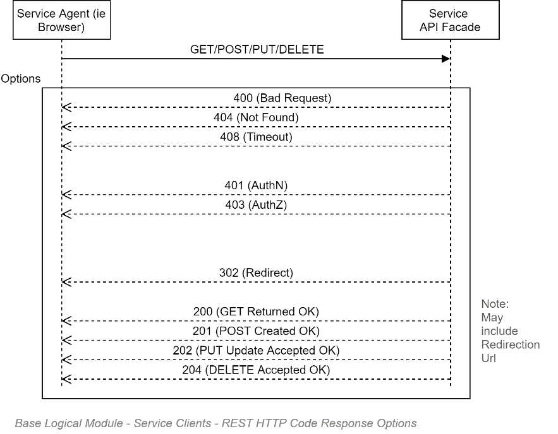

REST URL Format
REST Users have the following characteristics:
- The URL define a unique Resource (Item or List)
- Modifiers, such as OrderBy, Filter By, Projections, Page Size, Page Number are all modifiers, and are therefore not part of the URL.
Common conventions include:
- The URL refers to the Plural of objects (i.e. Persons, rather than Person)

The above characteristics mean that the following are valid examples:
GET:
- http://localhost/client/234/invoices/
- http://localhost/client/234/invoices/page/3/
Note: fails as URL should not have Pg info (it's a modifier).
- http://localhost/client/234/invoices/page/3/records/20
Note: fails temporal Pg or Size modifiers should be args, not URL.
- http://localhost/client/234/invoices/?pages=3
- http://localhost/client/234/invoices/?pages=3&records=20 ß URL http://localhost/client/234/invoices/16-24 <- a specific set is ok
- http://localhost/client/234/invoices/id/16-24
- http://localhost/client/234/invoices/?date=filtering ok...

REST FAQ

Q: REST is designed for individual Updates. What about Lists?
You must develop an UpdateXXXRecords Operation that can be PUT to with a set of objects.

Integration

Security
A key integration point is between the system itself and an external Identity Provider (IdP). The process is complicated by the fact that the security landscape has changed over time, but older documentation still abounds.

Protocols
The following is a subjective attempt to remember what happened over the past 20 years. Its intent is not to be perfectly accurate record of progress, but simply be a very high level context view to facilitate discussions and decisions elsewhere.

Era #1: PreWeb: Internal Applications, inside the LAN
In the beginning, Windows based enterprises used Active Directory derived Windows Identities to dynamically authenticate users. The advantage was that it provided relatively seamless access to internal apps (e.g.: Access, etc.) to corporate users. A key disadvantage was that the protocols used were tied to non-HTTP ports limiting collaboration with partners from outside the corporate LAN.

Era #2: Early Web: BASIC Protocol
The web developed outside of the Windows environment and did not/could not use LAN based authentication over HTTP ports. Early web applications stored usernames and passwords within the system's database. The protocol used was clear-text BASIC over HTTP (HTTPS if one was very lucky).

Era #3: Early Web: BASIC over limited HTTPS
The use of HTTPS was computationally heavy before dedicated hardware changes became universal. Hence the avoidance of HTTP for anything but the login page which still used BASIC.

Era #4: SAML
The SAML protocol was developed by the big companies (MS, Oracle, etc.) to work on existing protocols still in use for most software at the time (i.e., corporate LAN/non-HTTP port-based software that banks were using) as well as the newly emerged Web protocol. Highly secure, highly capable, it became the standard for environments needing a non-BASIC authentication mechanism.
SAML was complex, using a lot of different mature technologies in order to remain transport channel agnostic (Signing and encryption Certificates, XML, back-channels, etc.) – when in fact, the whole world was moving to HTTP/S, where the most needed/used features were already available (HTTPS).
Over time, SAML became perceived as overly complex therefore unduly expensive and time consuming to implement for the most common scenarios that people needed.

Era #4b: ADFS
Microsoft's reputation relies heavily on its security profile, so was loath to move away from its proprietary AD based standards to open source standards it could not control easily. MS developed a proprietary fork of SAML that larger companies (Oracle, etc.) implemented.
One could describe it as Microsoft attempting to dragging its venerable AD -- designed originally for the LAN so 25 years earlier – up to the WWW WAN, by exposing an API to broker its exposure to the web, over a proprietary variation to SAML.

Era #5: OAuth
In the meantime, others were trying to sever ties with LANs and move everything to the WWW WAN.
OAuth was developed to allow web services from different LANs to communicate, over HTTPS.

Era #6: AAD
Whereas Microsoft developed ADFS to expose legacy LAN for reuse by Web applications, they finally saw the writing on the wall that LANs have no future, and therefore AD had no future.
They put development of AD to rest, broke with the past, and rewrote a new directory service, from scratch, for the web era, over HTTPS.
Note:
For pure marketing purposes they called it Azure AD. When in fact it has very little to do with the original AD beyond being also a directory service.

Era #7: OAuth Proprietary Extensions for AAD
OAuth is an extensible Service to Service authorisation protocol. Whereas AD is most often used to authenticate persons. Microsoft had to extend the protocol for its own use to align with its new AAD capabilities.

Era #8: OAuth Extensions
AAD's OAuth extensions were not the only extension to OAuth. Facebook did the same thing for their needs. Some of the ideas within the Facebook implementation made it into the OIDC protocol that is now becoming the standard for authenticating persons (you still use OAuth to authenticate systems to systems).

Era #9: OIDC
OIDC is an extension of OAuth specifying what information to transport over OAuth, and how to package it and sign in. This allowed OAuth – which is intended for Service to Service Authorisation – to be extended to be used to authenticate Users.

Era #10: AAD OIDC
Microsoft has recognised that OIDC is the most widely desired protocol and has added it to AAD, beside its original extended OAuth protocol.

Recommended Protocol
As it stands, it may be that the customised OAuth AAD protocol has still more functionality than can be squeezed into an open protocol such as OIDC – but it is our professional opinion, considering the above history, to err on the side of open standards, and prefer OIDC for authenticating Persons on this project. And use OAuth to authenticate remote client Systems.

Making the document a GLAD (Gloriously Long Architecture Document)?
https://en.wiktionary.org/wiki/journ%C3%A9e
https://docs.microsoft.com/en-us/azure/active-directory/managed-identities-azure-resources/
https://docs.microsoft.com/en-us/sql/connect/jdbc/connecting-with-ssl-encryption?view=sql-server-ver15
https://docs.microsoft.com/en-us/sql/relational-databases/native-client/features/using-encryption-without-validation?view=sql-server-ver15
https://owasp.org/www-project-api-security/
http://www.w3.org/Protocols/rfc2616/rfc2616-sec10.html
Feel free to recommend corrections.

